**Our Vision and Values**

**‘working together for excellence’**

We believe the characteristics of an effective school are:

* Being a Child Centered School;
* Providing high quality teaching and learning;
* Providing high quality, effective leadership;
* Being a school strongly connected to its local community.

Our purpose therefore is to be an excellent school. We continually strive for excellence in every area of school life. To achieve this aim we must always have the right school **vision and values** and these must be at the heart of all that we do. Our mission statement in Victoria Primary is:

**‘To create a safe, happy learning community where together we inspire and equip our children so that they fulfil their potential, use their talents and follow their dreams now and always.’**



Welcome

**A warm welcome to our school. We hope you find the information in this prospectus useful.**

**In Victoria Primary we are very proud of our strong pastoral care and proud of our historic high standards in academics, sport and music.**

**We thrive on seeing our pupils grow, develop and mature as they journey with us over their first 8 years of schooling.**

**We are a school that promotes values, welfare and respect and inspires its pupils through expectation, challenge, passion and provision.**

**We look forward to you and your child joining with us.**

**We hope your child enjoys every day in Victoria Primary.**

**Mr John Armstrong Acting Principal**

**Mrs Joanne Rodgers Chairperson - Board of Governors**

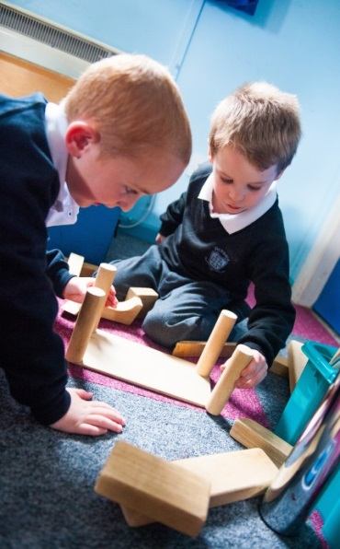

‘A very good school… a very good Nursery Unit’

[](http://www.google.co.uk/url?sa=i&rct=j&q=&esrc=s&source=images&cd=&cad=rja&uact=8&ved=0ahUKEwjXl72MwrnQAhXkDMAKHXz3Bp8QjRwIBw&url=http://www.castledawsonprimaryschool.co.uk/&psig=AFQjCNFPyWmsLl1ZGLrBfYsOyMHtHjfeMA&ust=1479806268165565)[](https://www.google.co.uk/url?sa=i&rct=j&q=&esrc=s&source=images&cd=&cad=rja&uact=8&ved=0ahUKEwjj29SnwrnQAhVnKsAKHchODUQQjRwIBw&url=https://www.etini.gov.uk/&psig=AFQjCNFPyWmsLl1ZGLrBfYsOyMHtHjfeMA&ust=1479806268165565)

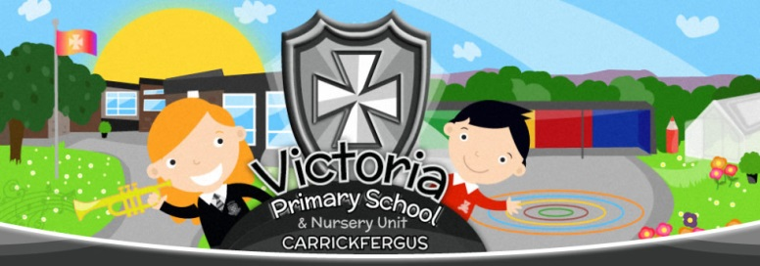

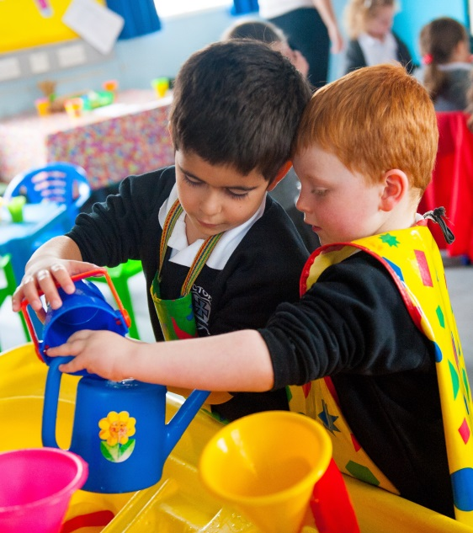

**As we strive to be always excellent we aim to:**

* **Value every child in our school family;**
* Make our learning environment as safe and as stimulating as possible;
* Ensure we have a strong school vision linked to our mission;
* Promote and celebrate excellence in learning at every opportunity;
* Develop and celebrate excellence in teaching at every opportunity;
* Ensure there is strong leadership throughout the school;
* Equip our pupils with the skills, knowledge and character to enjoy a successful, peaceful and content life;
* Promote a sense of stewardship in pupils for the community and environment in which they live;
* Continually consult all of our school community about our provision;
* Strategically plan to meet the needs of all our pupils using all resources available;

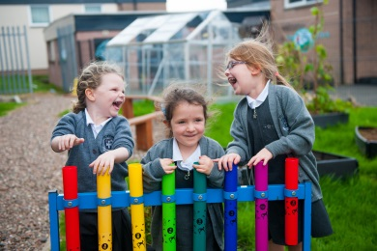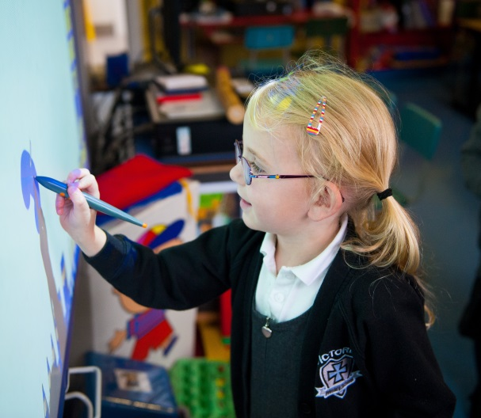

**PASTORAL CARE**

In Victoria Primary School we are committed, above all else, to providing each pupil with the best opportunities to develop their full potential, socially, academically, morally, emotionally and physically. We also aim to provide the best for every pupil in terms of their safety and welfare. We offer strong learning and wellbeing support and have a wide range of after school activities on offer.

*"A sincere thank you to a school that puts it pupils first, demonstrates excellent pastoral care and facilitates a safe environment that inspires and encourages inquisitiveness from the children" – parent quote*

**SAFEGUARDING**

In Victoria, we understand that we have a primary responsibility for the care, welfare and safety of the pupils in our charge. This charge is taken very seriously and we always carry out this duty as effectively as possible. We may on occasion need to discuss matters with other agencies but it always in the best interests of your child. All adults receive child protection training each year and visitors report in and out wearing visible passes. All of our learning community are involved in our safeguarding policy development and all parents are given information relating to child protection/safeguarding each year.

All medical conditions and resulting requirements are documented and displayed where necessary. Please contact the school to inform us of any medical conditions.

**WHO TO CONTACT IN SCHOOL**

For any concern regarding safeguarding in school please contact:

Designate Child Protection Teacher **Miss Jill Minnis**

Deputy Child Protection Teachers

Mr John Armstrong and Mrs Pamela Addis.

**CITIZENSHIP AND BEHAVIOUR**

The purpose of our school’s policy for behaviour and citizenship is to:

* Encourage and praise good behaviour;
* Prevent and discourage inappropriate behaviour;
* Deal with inappropriate behaviour in a fair and consistent manner;
* Develop behavioural skills in the pupils that will benefit both them and the community in which they live and learn creating a calm learning culture
* Have effective anti-bullying procedures

Rewards and sanctions all centre around the Golden Rules:

 **Our School Golden Rules!**

Do be kind and helpful do not be unkind or unhelpful

Do be gentle do not hurt other people

Do listen do not distract or talk over others

Do work hard do not be deliberately idle in class

Do be honest do not tell lies

Do look after property do not damage property

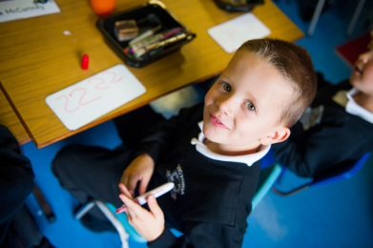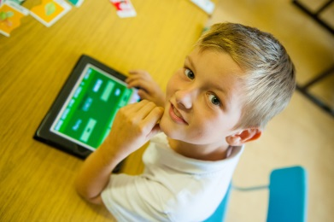

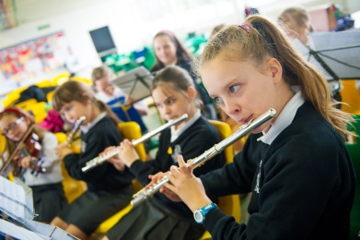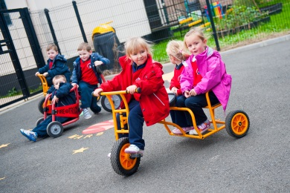

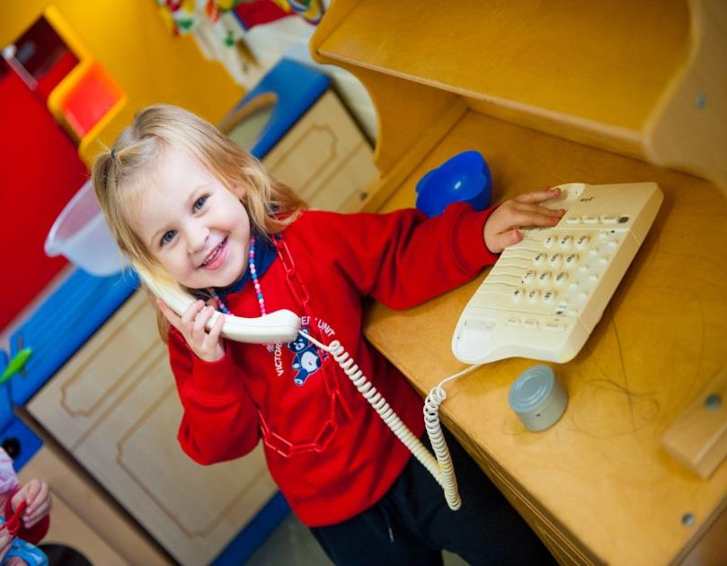

**Reading**

**Reading development is crucial to your child’s learning and progress in school. In Victoria Nursery we have the ‘Big Bedtime Read’ designed to support parents as they read with their children at bedtime each night. This interaction creates a strong bond, as well as an understanding about the meaning of pictures, text and the structure of reading. Reading at home helps reading in school.**

**Early mathematics**

**Your child’s environment is saturated with early maths learning opportunities. Touch counting toys and breakfast cereals, looking at shapes in everyday objects and signs as well as using mathematical language like more than, less than, smaller, longer, taller, heavier etc.**

**Early Years Provision**

**Learning and teaching**

We are a ‘very good’ Nursery (ETi 2013) and our pupils are provided with a rich variety of stimulating and challenging activities. The focus is to allow a child to learn at their own pace, gain a positive image of themselves as learners and develop a resilience to manage emotions and behaviours. Through play and other experiences the pupils have opportunity to learn in the following curricular areas:

* Language Development
* Early Mathematics
* Personal Social & Emotional Development
* The Arts
* Physical Development
* World Around Us

**Steps into year 1**

We have a strong link between our nursery and year 1 in Victoria. We share the same space, we have lots of transition time between classrooms and teachers and we share resources.

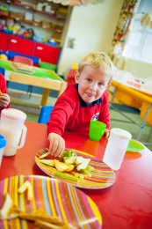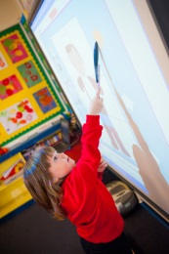

**Induction for Nursery Intake**

On acceptance of a place in Victoria Nursery parents are invited to an evening meeting in May/June with the school principal and Head of Nursery Mrs Addis. Parents will then receive a specially designed handbook to guide you through the year. In June your children are invited to school to meet the teacher and the assistants.

**Preparing for School**

The months before your child starts Nursery are as important as their first day. This time is vital for preparing your child so that transition is smooth and successful. It is important that you the parent promote a feeling of trust in the school and teachers. Your child should feel safe, secure and part of the whole school family.

**Facilities and learning**

**Learning is the beginning of an enjoyable experience based on the development of the child’s natural sense of curiosity and wonder.**

**In Victoria Nursery Unit we seek to partner with parents to broaden the child’s experiences and continue the education that began at home.**

**To best support learning we provide excellent facilities. Our Nursery Unit boasts 2 beautiful and bright classrooms equipped with interactive technology, iPads, a generous cloakroom and waiting area and a wealth of vibrant learning equipment.**

**The amazing facilities extend to outside where the pupils are encouraged to participate in extensive learning activities regardless of the weather using their Nordic suits!**

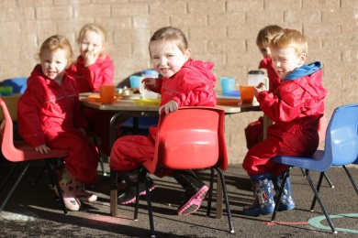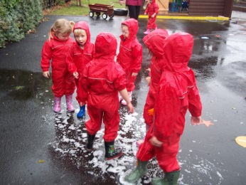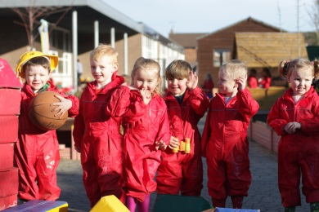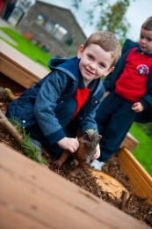

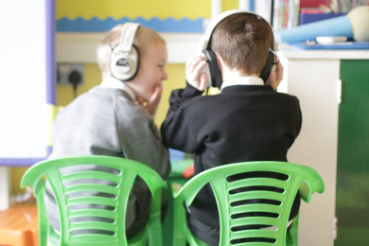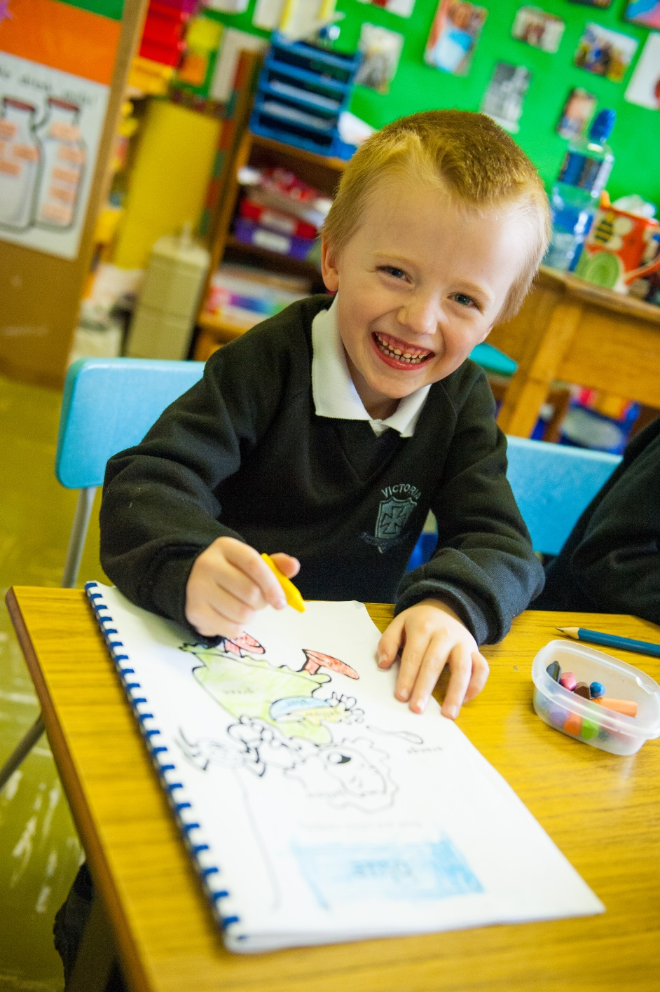

**Learning and the Curriculum in Foundation Years**

In years 1 & 2 we offer a wide and balanced curriculum designed to meet the needs of all pupils. The pupils will have opportunity to learn in 7 curricular areas: Language and Literacy, Mathematics, Personal Development and Mutual Understanding, Physical Education, The Arts, The World Around Us and Religious Education. They will use ICT to support their learning throughout year 1 as well as developing their skills in problem solving, working with others, managing information and being creative.

Our Foundation classrooms are vibrant. We provide high quality teaching, opportunities for formal and active learning. The pupils also continue to learn through play based activity. Before our pupils begin year 1, we meet with you the parents to start to talk about your child about their strengths, areas for improvement and their concerns. We operate a home school book system so that you can let us know about any issues concerning your child on a daily basis if needed or we are happy to talk after school.

**What to expect in year 1**

Our pupils experience a smooth transition into year 1 from our Nursery and other Early Years settings. We hold transition information meetings with our Nursery each year and with the other providers. We also meet with our new parents in term 1 as we understand that a good relationship with our parents is vital. Our pupils have a staged entry into year 1 each September to help them settle carefully and happily into their new surroundings.

Each day will follow learning in the 7 curricular areas and include healthy break and lunchtime. Pupils will be closely monitored in terms of progress over the year. Parents will have 2 formal consultations with the teacher and many informal conversations throughout the year to discuss their child’s progress. We also hold parental curricular evenings during term 1 for Phonics, Numeracy and Literacy. See the year 1 parental pack for more information via the school website **www.victoriaprimary.org.uk**

**Foundation Years**

**CHILD CENTRED FOUNDATION STAGE**

**At Victoria Primary School we aim to meet the needs and aspirations of the pupils within the school**

**We aim to create a warm and positive whole school ethos, reflected in the attitudes of staff, pupils and parents. We also aim to provide a positive learning environment for all pupils where their learning is encouraged and developed within the context of their individual needs, talents and abilities.**

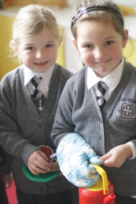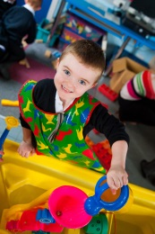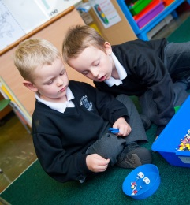

**The school day in year 1**

Our year 1 pupils arrive at school at 8:50 and enter through the year 1 door. They will have break from 10:30 – 10:45 and lunch from 12:15 – 1 pm each day. They will leave for home at 2 pm each day (excluding September).

**‘I love my school’** – year 2 pupil

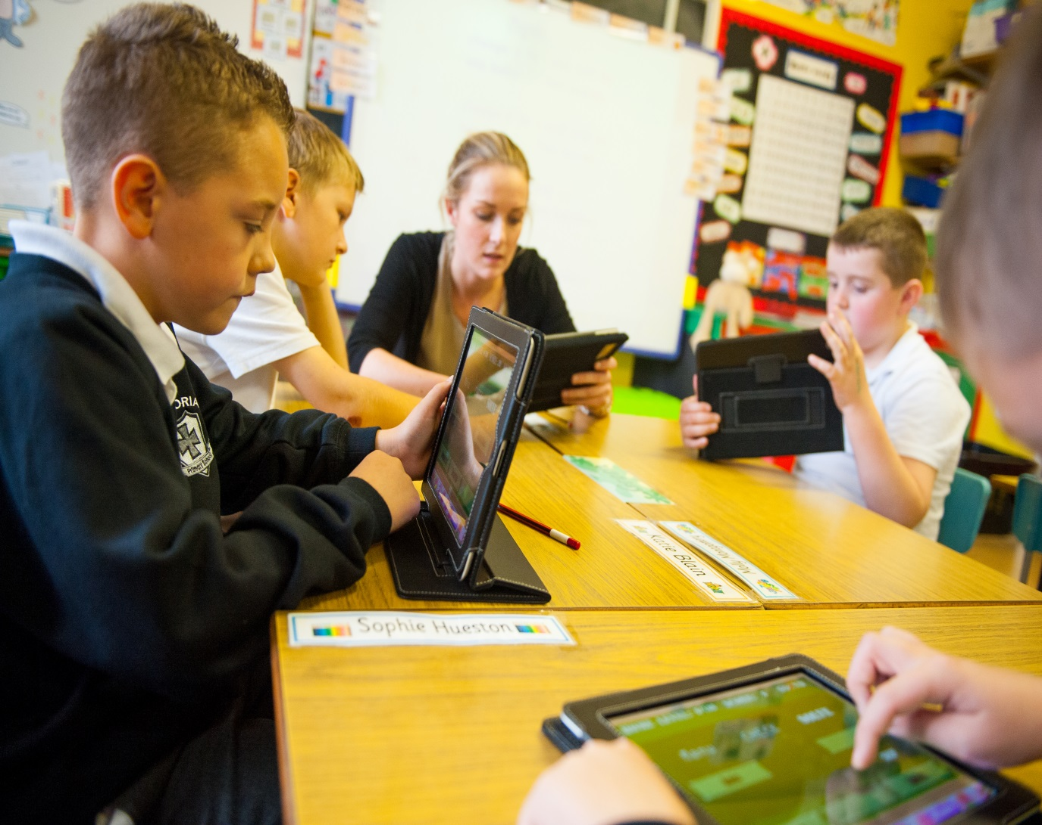

**Key Stages 1 and 2**

**Learning and the curriculum**

Key Stage 1 is years 3 and 4 and Key Stage 2 is years 5 – 7.

In Victoria we offer a wide and balanced curriculum designed to meet the needs of all pupils and to help them reach their full potential. The pupils will have opportunity to learn across 7 areas of learning: Language and Literacy, Mathematics, Personal Development and Mutual Understanding, Physical Education, The Arts, The World Around Us and Religious Education. Everyone is taught skills of problem solving, working with others, managing information and being creative. Pupils work individually, in pairs and groups each week and are directly involved in their own learning and assessment. Our excellent staff aims to motivate and inspire pupils in their learning through active, differentiated and challenging activities. Our pupils have access to a well-resourced range of ICT equipment to help support their leaning.

**Assessment**

Pupil progress is monitored closely daily and pupils are formally assessed in spelling, literacy and numeracy in September and May each year. This progress is discussed with parents through parental consultation and end of year reports sent home in June.

Teachers and school leaders use assessments to inform planning, to set school and class targets and to organise learning groups. ICT is also formally assessed in years 4 & 7 although each year group has a development scheme and monitoring and evaluation procedure.

**Special Educational Needs (SEN) and inclusion**

In all year groups, pupils with specific educational needs are closely supported by teachers, assistants, leadership and the school SENCO Miss MInnis. We believe that parental support is extremely important to the success of pupils with SEN. Where appropriate we will involve outside agencies to support learning and teaching. Individual learning plans will be discussed with pupils and parents.

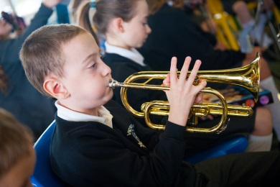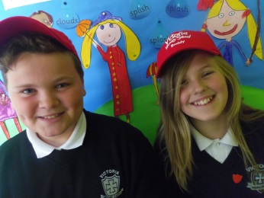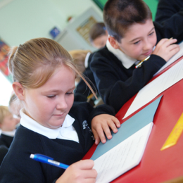



**Years 3 - 7**

**Department of Education ETI quotes**

**‘the quality of education is very good’**

**‘the exemplary behaviour of the children’**

**‘the effectiveness of teaching and learning’**

**‘the pastoral provided by this school is very good’**

**‘the school is meeting very effectively the needs of the children’**

**‘the school demonstrates a capacity for sustained self-improvement’**

**Parental involvement**

We understand that parents are key to learning success in school. We encourage parents to attend school events and to help support their child in their learning at home. We actively seek parental comments and suggestions to help us improve. Parents can make appointments to meet with the class teacher or the leadership team. We hold biannual parental consultations and run several parental curricular and information evenings during the year. We also have a thriving PTA that contributes to the school community both financially and socially.

**Homework**

We believe that parental involvement in learning at home is key to learning success in school. Pupils will be encouraged to complete reading, number facts and written homework each week. This increases as the pupils move from year to year. Homework is designed to support pupils and involve parents and at no time should be a source of tension in the home .

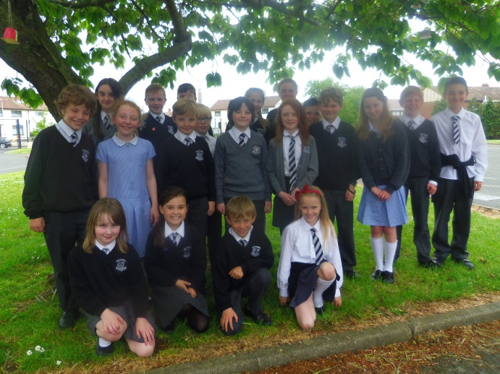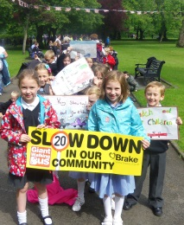

**Pupil Voice**

We believe in pupils having input into their own learning. Each term in school curriculum leaders and the SENCO talk with pupils about their learning.

**School Council**

***‘school council is brilliant…we get to make lots of decisions’ – school council member***

Our elected school council meets on regular basis and involves pupils in years 4 – 7. The council offers each class an opportunity to have their voice heard in the leadership of the school and it runs a variety of school events each year.

Schooo day

Healthy School

**Board of Governors**

*‘I have served on the board for 22 years and believe this is a great school that always aims to improve the learning and attainment of its pupils.’ – Chairperson*

Members of the Board of Governors of Victoria Primary represent the staff, parents, churches, Education Authority and the general public. The Board bring a wide range of strengths and community interests to Victoria Primary. They meet with the school Principal on a regular basis to govern school matters including finance, school improvement strategies, the curriculum and safeguarding/child protection.

**Staff**

Our talented teachers play an essential role in the delivery of the curriculum and the attainment of our pupils. They work hard to create a stimulating learning environment, one that motivates pupils and unlocks their will to learn and develop. A current list of staff can be viewed via the school website [www.victoriaprimary.org.uk](http://www.victoriaprimary.org.uk)

**Who to contact?**

If you need to contact school please speak to Mrs Moffett the school secretary on 02893351781.

Below are key points of contact:

* Mrs Rodgers Chairperson Board of Governors
* Mr Armstrong Acting Principal
* Mrs Orr Acting Vice-Principal/ Head of Foundation & Key Stage 1
* Miss Minnis SENCO/ Pastoral Care/ Designated teacher for Safeguarding & Child Protection
* Mrs Addis Head of Nursery
* Mr Stevenson School Cook
* Mr Tweedy Building Supervisor

Tel: 02893351781

www.victoriaprimary.org.uk

E:mail:victoraprimary@hotmail.co.uk



**Attendance and Punctuality**

**Victoria has an annual whole school attendance of over 96% including the Nursery Unit** and month to month we have over 300 pupils achieving 100% attendance. We ask that families telephone or send in a message stating reasons for an absence as soon as possible or on the first day of return to school.

We also ask that pupils arrive on time each morning as it is very unsettling for pupils if they have to walk into their classroom late after the learning has started for the day. At the end of the day we ask that parents ensure that appropriate arrangements have been made for their child’s pick up. Pupils are all taught to come back to the school office if they are not collected or if they are unsure about collection arrangements. Please read our ‘We Care for You’ and ‘Safeguarding’ leaflets on the school website.

We may, on occasion, send home notes regarding punctuality and attendance. This is to keep families informed and is in the best interests of the pupils.

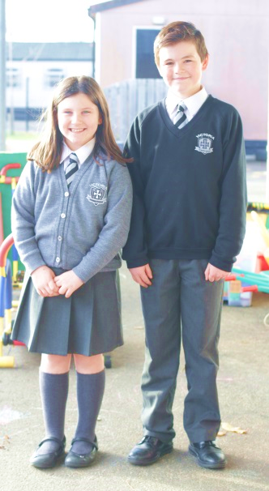

[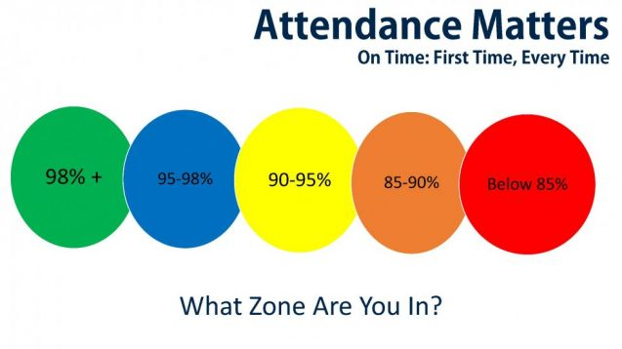](http://www.google.co.uk/url?sa=i&rct=j&q=&esrc=s&source=images&cd=&cad=rja&uact=8&ved=&url=http://www.stmarysstewartstown.com/parents/deni/&bvm=bv.139782543,d.ZGg&psig=AFQjCNHEqTcUUH_fpl-0VmKYmRdJPwvxqw&ust=1479911208964093)

**School Uniform**

Our uniform in Victoria is both distinctive and incredibly smart. We believe that uniform allows pupils to focus on their learning rather than appearance. Our Board uphold a strict uniform policy. We believe that our pupils take pride in being recognisable as members of Victoria. Hairstyles should be appropriate without lines and dyes. Jewellery and make up are not permitted for health and safety and safeguarding reasons.

|  |  |
| --- | --- |
| **Boys wear:** | **Girls wear:** |
| White shirt and tie | White blouse and tie |
| Black jumper/ school sweatshirt | Grey cardigan/jumper/ school sweatshirt |
| Dark or mid grey trousers | Dark or mid grey trousers (plain bootleg style only!)  Grey pinafore/skirt |
| Black shoes | Black shoes |
|  | **Summertime :** Blue checked dress |
| **PE: t:shirt & shorts plimsolls or trainers** | **PE: t:shirt & shorts plimsolls or trainers** |

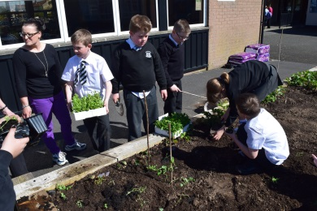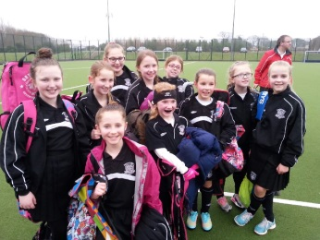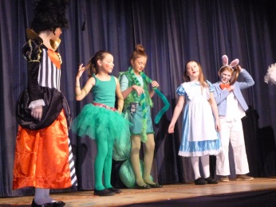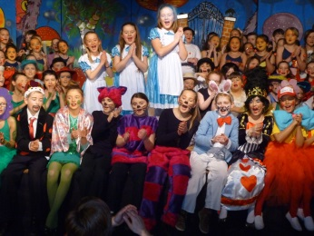

**Our Extended School Activities**

In Victoria we offer the widest range of after school activities of all schools in the area. We offer the following activities:

Football, netball, hockey, badminton, rugby, tennis, Ju-Jitsu, French/Spanish, Jesus and Me, eco club, gardening club, senior choir, junior choir, orchestra and Irish dancing. We also have a school digital leaders team, a school digital newspaper team and a large and active **school council. We have school teams representing many activities.** We also offer a very popular **breakfast club** in the school canteen, which operates from 8 a.m. each morning at a cost of £1.75 a day.

**Our School Productions**

We perform a school production every other year and involve as many of our year 6 and 7 pupils who wish to take part. It is a great opportunity for pupils with musical and acting talent to perform in front of large audiences. We also have nativity plays every other year for our Nursery – year 4 pupils.

**Our Community**

We value our school staff and pupils, our parents and our neighbouring community. We hold strong links with local churches and businesses. We send year 6 and year 7 pupils to all our post-primary schools each year for a variety of events including open days, sporting events and plays.

We hold our annual Community Carol Service in North Street Presbyterian each year and a summer concert in school.

We hold various curricular and social events for our parents as well as the other school concerts and productions and many of these events are strongly supported by our school PTA.

Admissions

School details

**Our Educational Visits**

In Victoria we offer our pupils opportunity to visit museums, farms, galleries and other countries to enrich our curriculum and their learning. Details in parent pack on website.

**Our Healthy School Meals**

We operate a healthy break system in school Monday to Thursday with Friday being a treat day. We offer an excellent canteen menu for school meals at a cost of £2:50 per day. Many pupils will eat a packed lunch. There are water fountains placed throughout the school.

**Safety & Security**

The safety of our pupils is one of our highest priorities. School gates and doors are closed at 9 a.m. after the pupils enter. No parents are allowed in the back playground or the school building at any time without going via the school office. The only door that pupils, parents and visitors can access after this time is the main entrance. All visitors sign in and out and wear visitor passes. All our pupils are taught these arrangements. The Nursery Unit has a dedicated entrance and a video unit to monitor visitors. All staff and volunteers are Access NI vetted.

**School Day**

Nursery a.m. session start 9 a.m. finish 12 p.m.

Nursery p.m. session start 12:30 p.m. finish 3 p.m.

Year 1& year 2 start 9 a.m. finish 2 p.m.

Year 3 (Mon. & Tues) start 9 a.m. finish 2:50 p.m.

Year 3 (Wed – Fri) start 9 a.m. finish 2 p.m.

Year 4 (Mon. – Thurs) start 9 a.m. finish 3 p.m.

Year 4 (Fri. only) start 9 a.m. finish 2 p.m.

Years 5 – 7 start 9 a.m. finish 3 p.m.

Parents are asked to leave their children to the playground no later than 8:50 a.m. Children cannot be left unattended before then as they are not supervised by staff until 8:50 a.m.

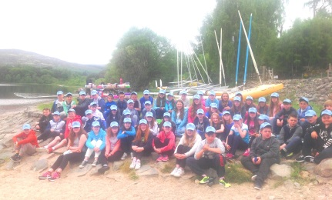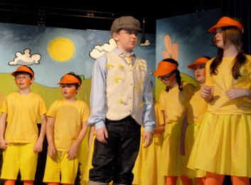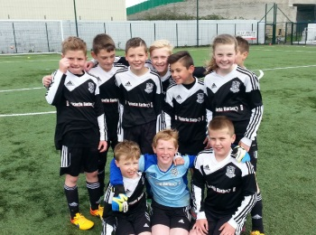

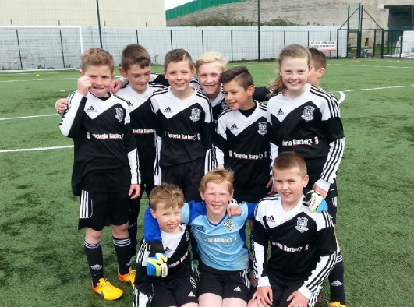

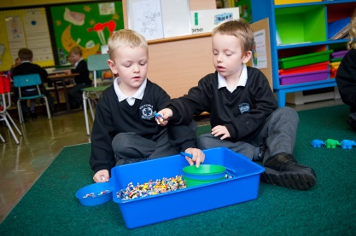

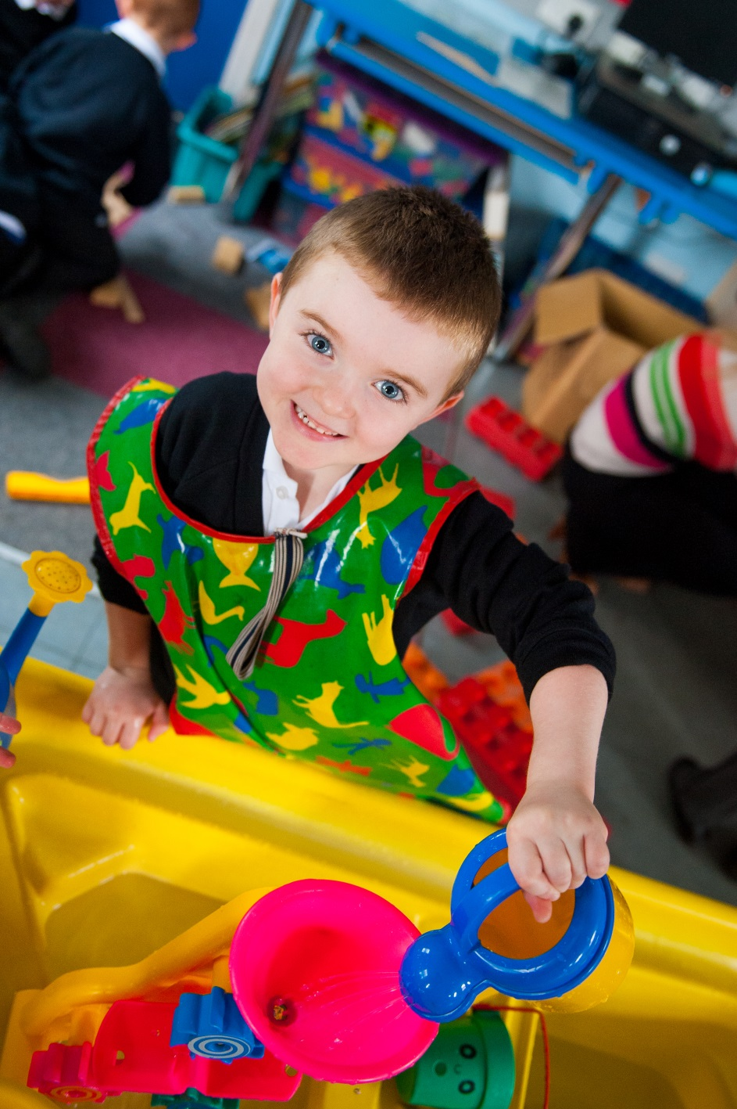

**Admissions**

Application forms are available from the school office for Nursery and Year 1. You will need a copy of your child’s birth certificate to accompany the form. If you have any queries or questions please contact the school office on 0293351781 between 9 a.m. and 4 p.m. We follow our admission policy and the Board of Governors adhere strictly to the published criteria (Please read attached sheet or visit the Education Authority’s website for further information on admissions and criteria [**www.eani.org.uk**](http://www.eani.org.uk)**/admissions**).

**School Details**

Victoria Primary School

Coronation Road

Carrickfergus

BT387EZ

Acting principal: Mr John Armstrong BEd. MEd. PQHNI.

Tel: 02893351781 Fax: 02893355990

E:mail [www.victoriaprimary@hotmail.co.uk](http://www.victoriaprimary@hotmail.co.uk)

Website [www.victoriaprimary.org.uk](http://www.victoriaprimary.org.uk)

[](https://www.google.co.uk/url?sa=i&rct=j&q=&esrc=s&source=images&cd=&cad=rja&uact=8&ved=0ahUKEwjj29SnwrnQAhVnKsAKHchODUQQjRwIBw&url=https://www.etini.gov.uk/&psig=AFQjCNFPyWmsLl1ZGLrBfYsOyMHtHjfeMA&ust=1479806268165565)[](http://www.google.co.uk/url?sa=i&rct=j&q=&esrc=s&source=images&cd=&cad=rja&uact=8&ved=0ahUKEwjXl72MwrnQAhXkDMAKHXz3Bp8QjRwIBw&url=http://www.castledawsonprimaryschool.co.uk/&psig=AFQjCNFPyWmsLl1ZGLrBfYsOyMHtHjfeMA&ust=1479806268165565)

**‘A very good school… a very good Nursery Unit’**

