
Victoria Primary School
Carrickfergus
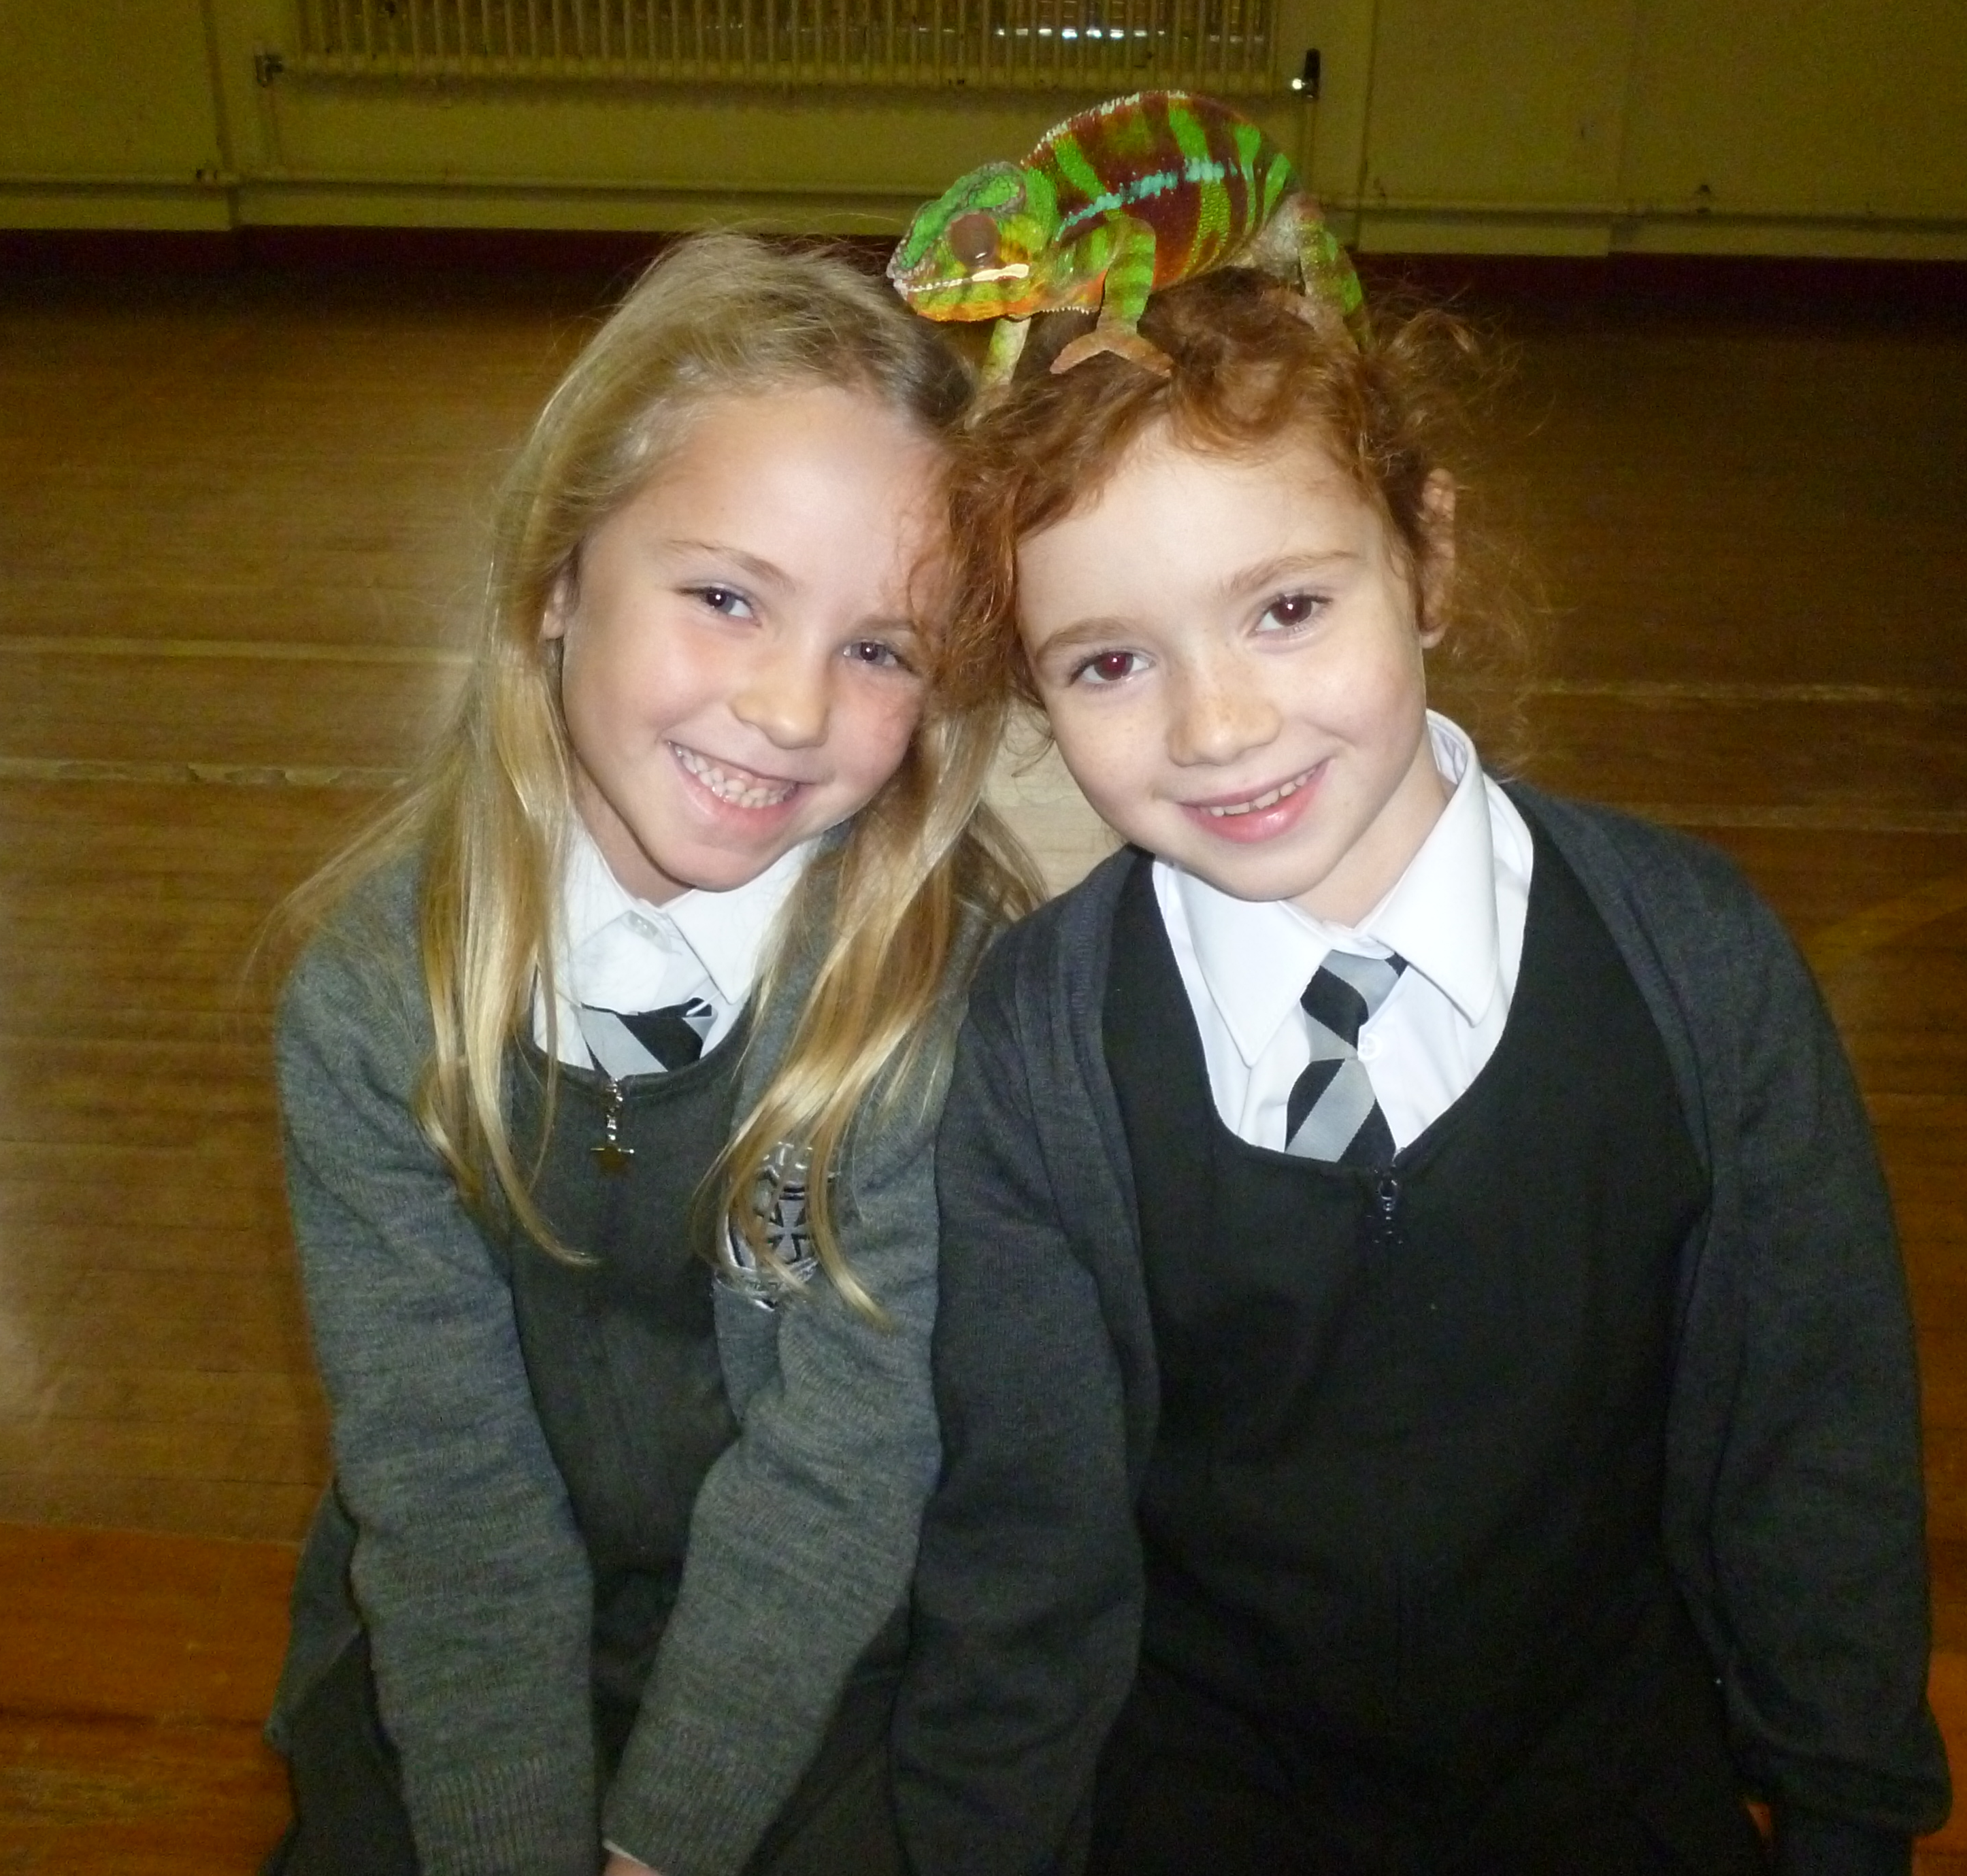

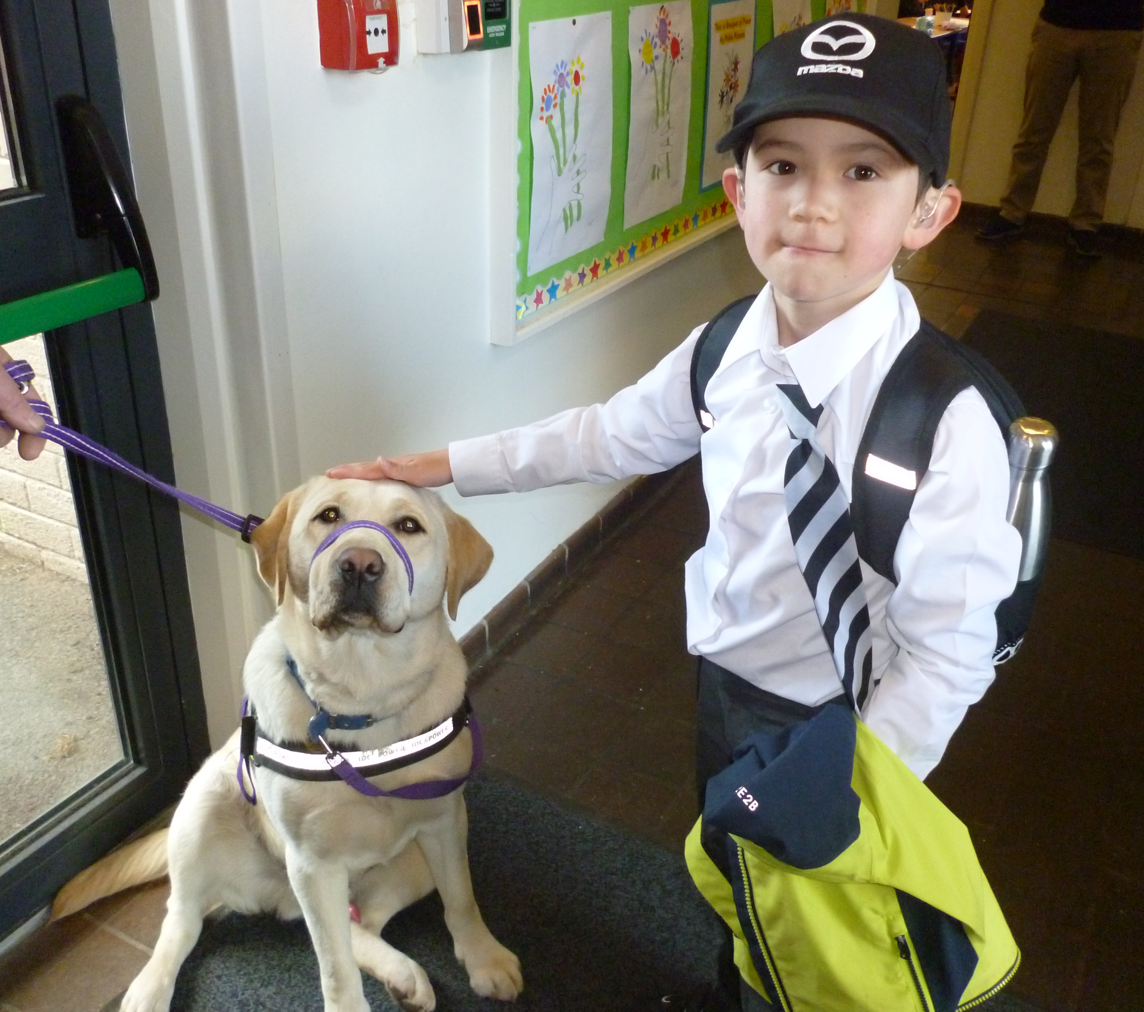
Parental
Information
Pack
Primary 3

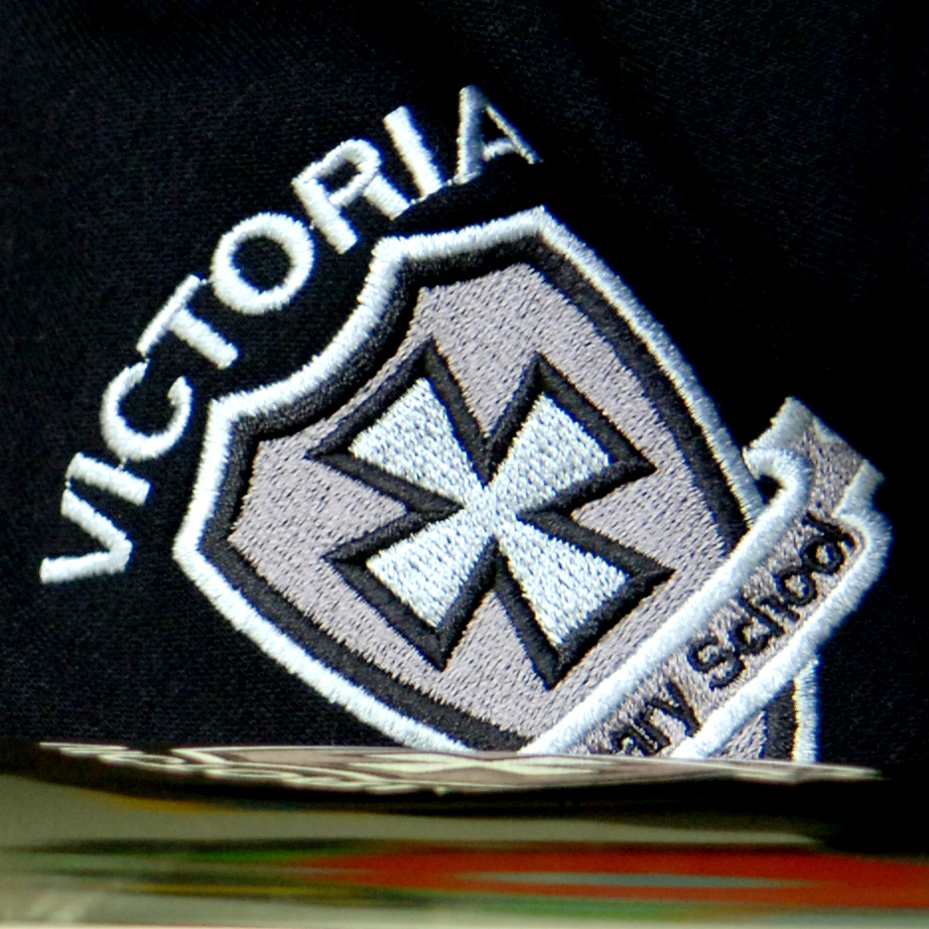


Working together for excellence

Welcome to Primary 3 Victoria Primary School

Hello parents/guardians
We are very pleased that your child has now started Primary 3 in Victoria Primary School. This information pack is designed to support you and your child throughout this year. Please read the information included and if you have any further questions please contact school on 02893351781. We look forward to meeting you at parental interviews and all other the various school community events that take place between September and June. Thank you for your support.

Contents

- Calendar information
- Information about Primary 3
- Maths topics
- Literacy topics
- World Around Us Topics

Calendar Information
2021/22

Please check the school website calendar for any additional dates.

Term Dates
August | Wed 25th – P2 – P7 return (half day and half classes – more info to follow)  Thurs 26th – P2 – P7 return (half day and half classes – more info to follow)  Fri 27th – P2 – P7 return (half day and full classes)  Mon 30th – School Closed (Public Holiday)
September | Wed 1st – P1 and Nursery children begin school. Specific dates and times will be communicated to individual parents.  Fri 24th – School Development Day (School Closed)
October | Mon 25th – School Development Day (School Closed)  Tues 26th – Fri 29th – Half Term (School Closed)
December | Tues 21st – School closes at 12pm for Christmas Holidays  Wed 22nd – School Development Day (School Closed)
January | Wed 5th – School reopens for all pupils in P2 – P7.  Nursery and P1 closed for Open Day.  Thurs 6th – School reopens for pupils in Nursery and P1.
February | Mon 14th & Tues 15th – School Development Day (School Closed)  Wed 16th – Fri 18th – Half Term (School Closed)
April | Fri 8th – School closes at 12pm for Easter Holidays  Mon 11th – School Development Day (School Closed)  Tues 12th – Fri 22nd – Easter Holidays (School Closed)
May | Mon 2nd – School Closed (Bank Holiday)  Mon 30th & Tues 31st – School Development Day (School Closed)
June | Wed 1st – Fri 3rd – (School Closed – mixture of holiday dates and bank holidays)  Thurs 30th – School closes at 12pm for Summer Holidays.
School Information

Principal Mr. Fulton
Vice-Principal Mrs. Kernaghan
Head of Foundation Mrs. Orr
and Key Stage 1
Head of Key Stage 2 Mrs Miskelly
Child Protection staff Mr Clarke/Mr Fulton /Mrs Addis/Mrs Kernaghan / Mrs Rodgers
Pastoral Care Mr Clarke
Special Education Needs Mrs Kernaghan
Chair of Governors Mrs Rodgers
Administrator Mrs Ritchie

School address Coronation Road
Carrickfergus
BT387EZ
02893351781
victoriaprimary@hotmail.co.uk

School Website www.victoriaprimary.org.uk

Parental information
Most parental information will be posted on the school website or sent out via our school app. (which is also accessible from SMART phones), including items such as canteen menu, holiday lists, monthly newsletters, policies and the welcome packs for each year group.

Queries
If you have a request or message Mrs Ritchie in the school office (02893351781) will pass on information to your child’s class teacher or make an appointment to talk to the staff member you require. Information regarding how to discuss concerns or complaints will be detailed on the school website or this information can be obtained from the school office.

Who To Talk To?
As you will be aware we are a large school. Mr Fulton (Principal) and Mrs Kernaghan (Vice Principal) are always willing to try to talk to as many parents / carers should any issues arise, however, this may not always be the case. It is important, to ensure that any query or concerns is dealt with quickly, that you follow the flow chart below in terms of who to contact first. Please do not be offended if Mrs Ritchie directs you to an alternative person on the list to make contact with first.

Contact Flow Chart

Class Teacher

Head of Key Stage
Mrs Orr for P1 – P4 or Mrs Miskelly for P5 – P7

Vice Principal
Mrs Kernaghan

Principal
Mr Fulton

Pastoral Care and Special Educational Needs (SEN)
The aim of all staff is to meet the needs of your child. If you have a concern about pastoral care, please call school and ask to speak with the class teacher of Mr Clarke (Pastoral Care Lead). Or if you would like to speak with someone about additional educational needs for your child please speak to the class teacher or Mrs Kernaghan.

Child Protection
Parents are given Child protection leaflets, E:Safety Acceptable Use leaflets, Pastoral care leaflets, What to Expect in each year leaflets and notes about praise, punctuality, attendance, uniform and photographs. The Child Protection Policy can be obtained via the school website and or through the school office. See below for how a parent can raise a concern.

How a parent/guardian can raise a concern

I have a concern about my / a child’s safety

I can talk to the class teacher in the Nursery Unit
or Primary School

If I am still concerned, I can talk to the Designated Teachers for Child Protection/Safeguarding
Mr J. Clarke
Mr Fulton /Mrs Kernaghan/Mrs P Addis

If I am still concerned, I can talk to the Principal
Mr C Fulton (Principal)

If I am still concerned, I can talk/write to the
Chairperson of the Board of Governors -
Mrs J Rodgers c/o Victoria Primary School
& Nursery Unit

At anytime, I can talk to a social worker at the Gateway Services or the PSNI Public Protection Unit, Newtownabbey.

Primary 3 information

General information
The Primary 3 teachers this year are
- Miss Morrow in Room 11
- Mrs McFadden in Room 12

The aim of the teachers in Primary 3 is to meet the needs of your child. It is a busy year for pupils, staff and parents as we together cover a very broad and exciting curriculum. Your support and interest is greatly appreciated.
We have an extremely high attendance rate in Victoria and believe it is important to your child’s learning that you support full attendance and punctuality.

Please ensure that your child has uniform clearly marked and that the uniform policy is adhered to (see website for details).

If you or your child has a question about school life or is unhappy about an issue please speak to your class teacher or other relevant staff members as outlined in school information above.

School times
School starts at 9:10am and P3 pupils can be in their classroom from 8:50am.
All P.3 classes enter through the front door in the mornings.
Room 11 exit through the side door at home time.
Room 12 exit through the side door at home time.

They are also welcome to attend our Breakfast Club in the school canteen from 8 – 8:50 am each morning at a small cost (contact school office).

Breaktime is from 10:20 – 10:45am and the pupils are encouraged to eat healthy break Monday – Thursday with a treat day on Fridays.

KS1 lunchtime arrangements:
12.00pm until 12.30pm packed lunch and dinners
12.30pm until 1.00pm outside play

The P3 week
Pupils will participate in Maths and Literacy lessons Monday – Friday. They will cover 5 topics over the year related to the ‘World Around Us’ (WAU). Please see below for details of these topic areas. They also participate in lessons in The Arts, PE, RE and PDMU (Personal Development and Mutual Understanding) much of which will directly relate to Maths, Literacy and WAU Learning Areas.
Time will be spent using the Computer suite and school library. They will participate in a school assembly (classroom based via zoom) one morning each week.

Homework
Reading will be carried out in school four days per week. Please continue to read with your children at home each evening.
Spellings and Tables will be given on three nights with revision on a Thursday night for the Friday test. A book (blue) has been sent home to practice writing out spellings each night. There will be a written homework worksheet set every Wednesday to be completed at home. Written homework on average should take 20 minutes. The written homework can be returned as soon as it is completed (Monday at the latest).

Parent volunteers
For Victoria to provide as many opportunities and experiences during the school year we need your help!
The children go on various outings throughout the year and this requires the support of parents. If you are available to help please fill in and return the Parent Volunteer form available from the school office.

P3 Curriculum topics

Below are the Maths, Literacy and World Around Us topics to be covered in each half term in school. All pupils will be provided with a wide range of appropriate, differentiated reading material throughout the year.

Half Term | Maths Topic
September - October | - Rote counting and number recognition to 100. Counting in 1s, 2s, 5s and 10s  - Place value  - Addition and Subtraction-vertical & horizontal and problem solving  - Number facts within 20 (tables)  - Mental Maths  - Missing numbers  - Equalisations (see-saw sums)  - Pictograms  - Bar charts  - Carroll diagrams  - Tree diagrams  - Time - O’clock and Half past – analogue and digital  - Money – recognition of coins and making amounts  - 2D shape (pentagon and hexagon)  - Fractions – half of a shape and number
October – December | - Rote counting and number recognition to 100. Counting in 1s, 2s, 5s and 10s  - Place value  - Addition and Subtraction-vertical & horizontal and problem solving  - Number facts within 20 (tables)  - Mental Maths  - Doubles and near doubles  - Story sums  - Odd and Even  - Money – recognition of coins and making amounts  - Pictograms  - Bar charts  - Tree diagrams  - Length  - Weight  - 2D shape (irregular shapes)
January – February | - Rote counting and number recognition to 100. Counting in 1s, 2s, 5s and 10s  - Place value  - Addition and Subtraction-vertical & horizontal and problem solving  - Number facts within 20 (tables)  - Mental Maths  - Story Sums  - Fractions – quarter of a shape and number  - Equalisations  - Find the difference  - Number language  - Number grids  - Tens and Units  - Venn Diagrams  - Pictograms  - Bar charts  - Money  - Time - Quarter Past  - 3D shape
February – April | - Rote counting and number recognition to 100. Counting in 1s, 2s, 5s and 10s  - Place value  - Addition and Subtraction-vertical & horizontal and problem solving  - Number facts within 20 (tables)  - Mental Maths  - Number grids  - Tens and Units  - Greater than/Less than (< >)  - Money – finding totals and giving change  - Venn diagrams  - Carroll diagrams  - Pictograms  - Bar charts  - Tree diagrams  - Time – Quarter Past (digital)  - 3D shape
April - June | - Rote counting and number recognition to 100. Counting in 1s, 2s, 5s and 10s  - Place value  - Addition and Subtraction-vertical & horizontal and problem solving  - Number facts within 20 (tables)  - Mental Maths  - Number grids  - Tens and Units (Decomposition)  - Problem solving  - Carroll diagrams  - Pictograms  - Bar charts  - Time problems  - Money – finding totals and giving change  - Weight  - Properties of 2D and 3D shape
English Topics
LITERACY  The following skills will be covered throughout all areas of Literacy over the course of the year. | The skills are:  - clarifying,  - understanding words,  - sequencing and retelling,  - making connections,  - comparing and contrasting, predicting,  - summarising,  - visualising,  - questioning,  - speculating and justifying,  - identifying the main idea,  - concluding,  - inferring,  - fact and opinion,  - cause and effect  - finding information.

WAU Topics
September – October | - Houses and Homes
November – December | - Dinosaur Detectives
January – February | - Incredible Inventions
March – April | - Ready Steady Grow
May - June | - Sandy and Salty

* Please note that the above is set out for general information only and pace of learning and variations in school life may necessitate some change to the delivery and timing of these Learning Areas.

