
Victoria Primary School
Carrickfergus

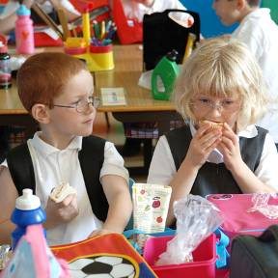
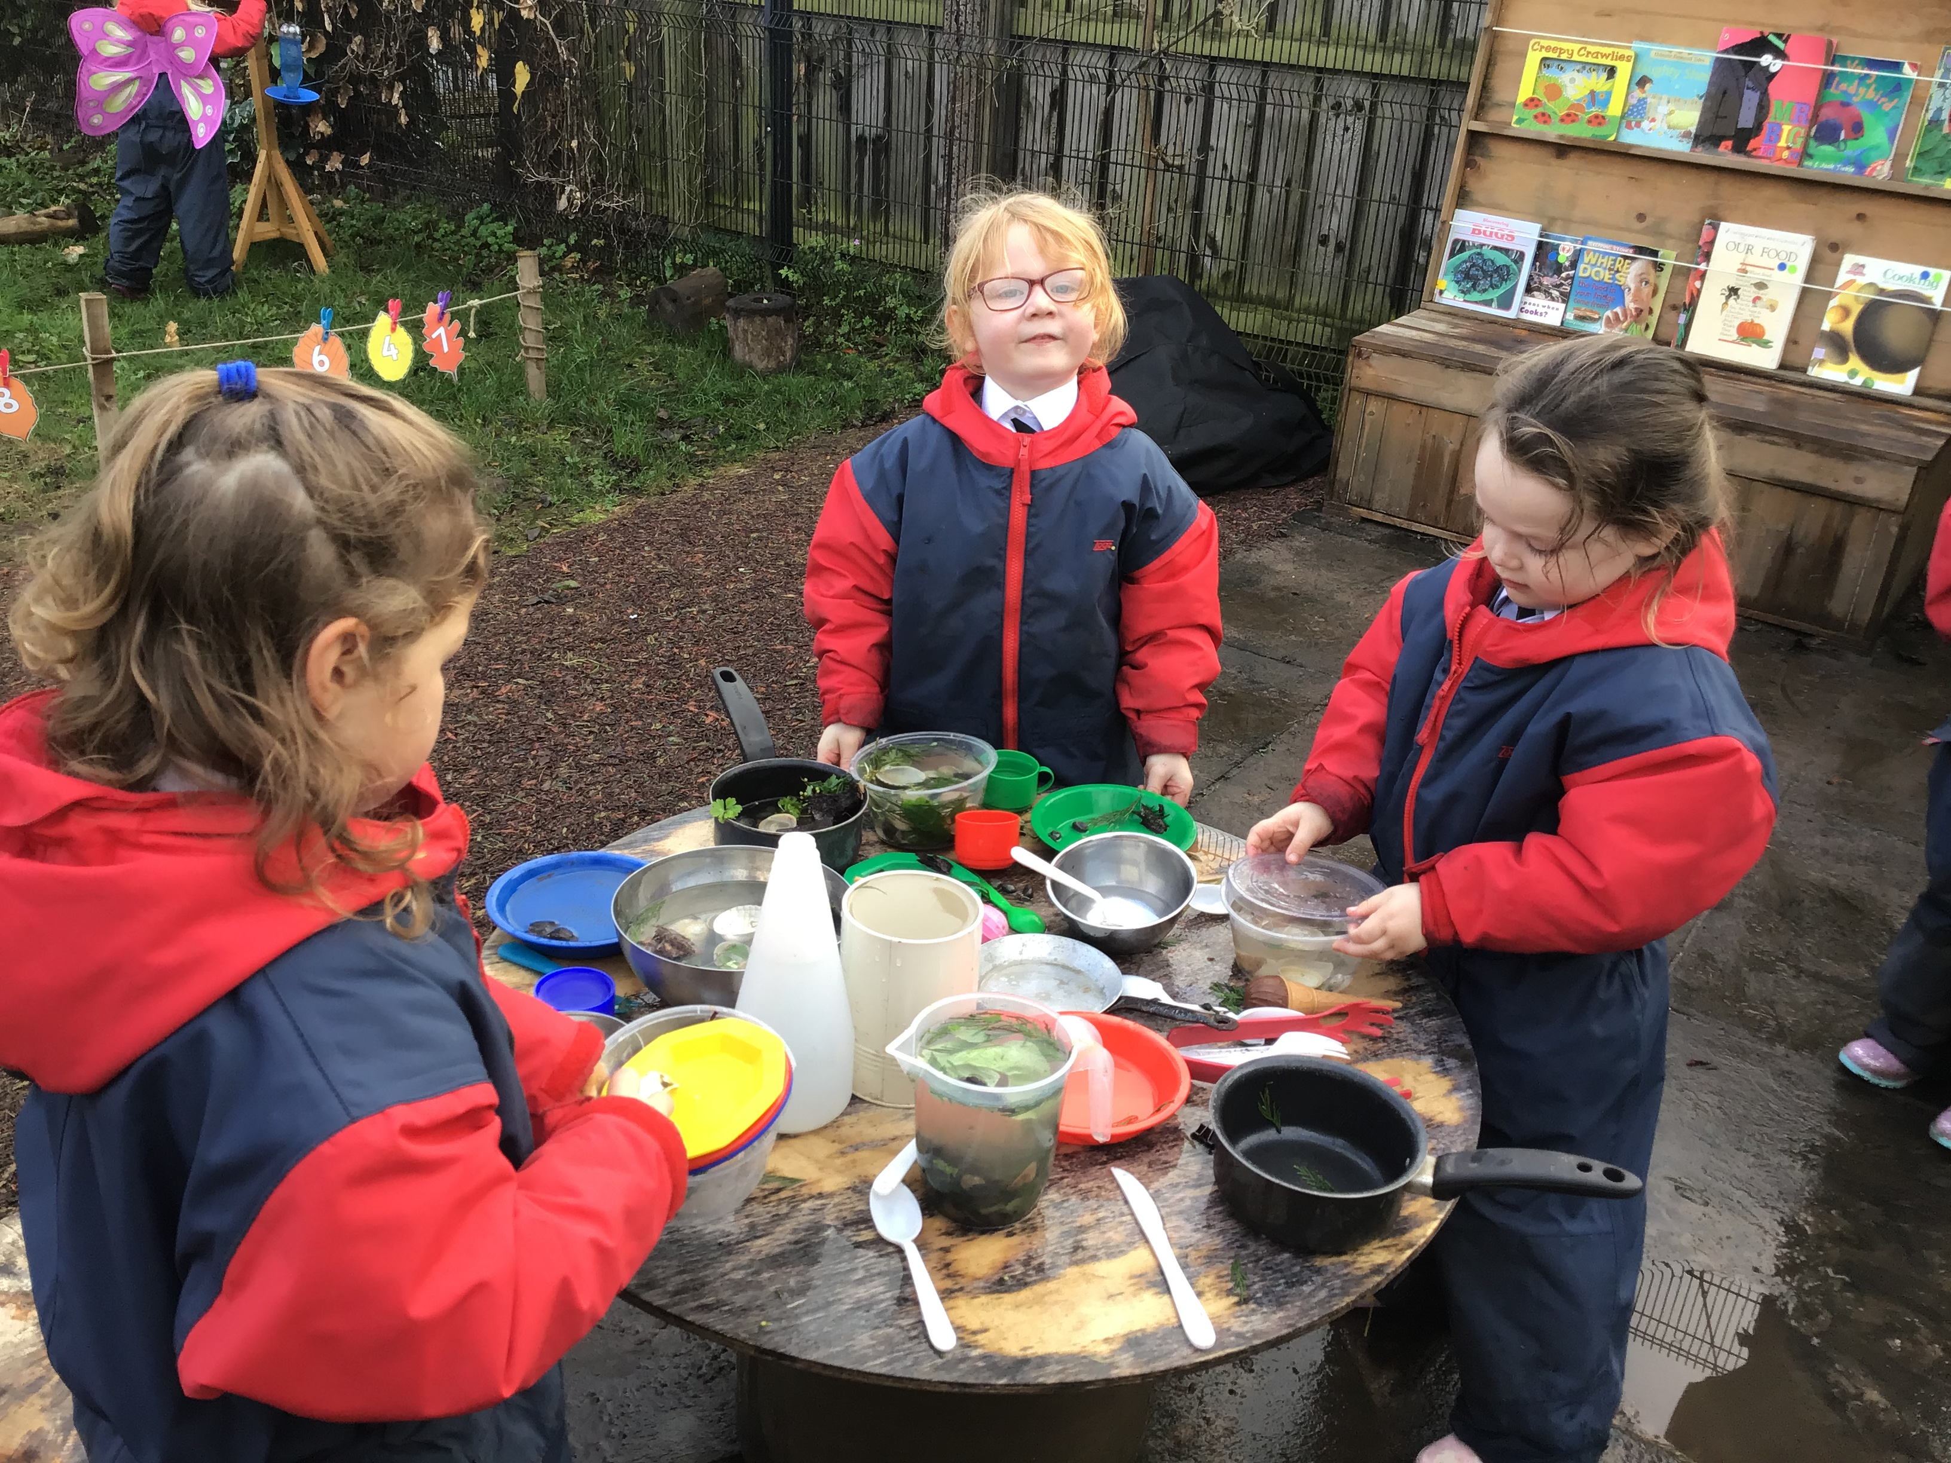


Parental
Information
Pack
Primary 1

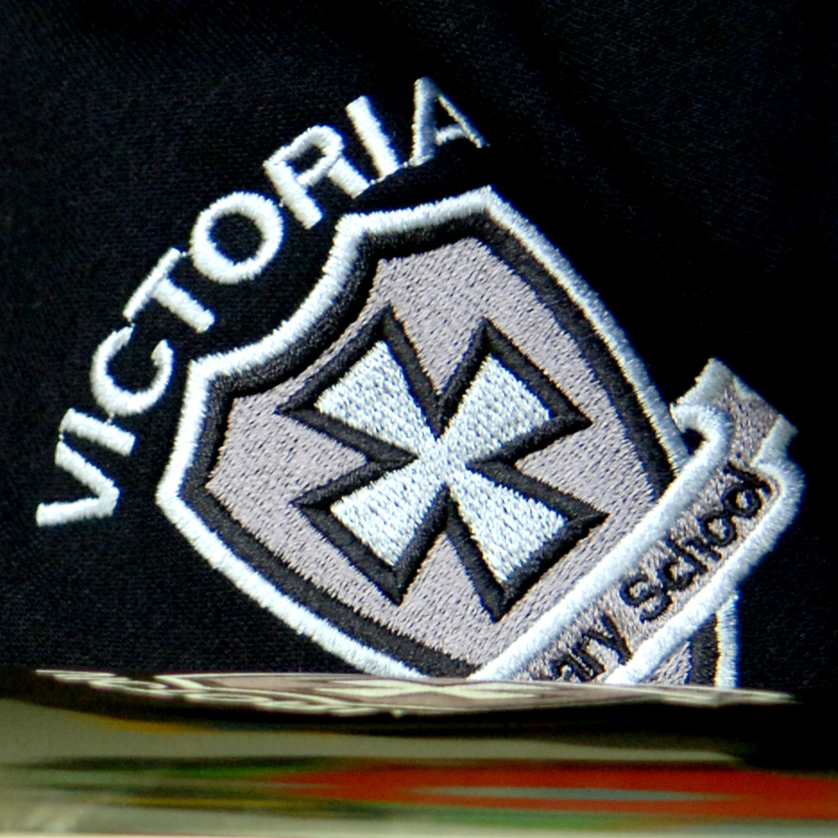


Working together for excellence

Welcome to Primary 1 @Victoria Primary School

Hello Parents/Guardians
We are very pleased that your child has now started Primary 1 in Victoria Primary School. This information pack is designed to support you and your child throughout this year. Please read the information included and if you have any further questions please contact school on 02893351781. We look forward to meeting you at parental interviews and all other the various school community events that take place between September and June. Thank you for your support.

Contents

- Calendar information
- Information about Primary 1
- Maths topics
- Literacy topics
- World Around Us Topics

Calendar Information
2021/22

Please check the school website calendar for any additional dates.

Term Dates
August | Wed 25th – P2 – P7 return (half day and half classes – more info to follow)  Thurs 26th – P2 – P7 return (half day and half classes – more info to follow)  Fri 27th – P2 – P7 return (half day and full classes)  Mon 30th – School Closed (Public Holiday)
September | Wed 1st – P1 and Nursery children begin school. Specific dates and times will be communicated to individual parents.  Fri 24th – School Development Day (School Closed)
October | Mon 25th – School Development Day (School Closed)  Tues 26th – Fri 29th – Half Term (School Closed)
December | Tues 21st – School closes at 12pm for Christmas Holidays  Wed 22nd – School Development Day (School Closed)
January | Wed 5th – School reopens for all pupils in P2 – P7.  Nursery and P1 closed for Open Day.  Thurs 6th – School reopens for pupils in Nursery and P1.
February | Mon 14th & Tues 15th – School Development Day (School Closed)  Wed 16th – Fri 18th – Half Term (School Closed)
April | Fri 8th – School closes at 12pm for Easter Holidays  Mon 11th – School Development Day (School Closed)  Tues 12th – Fri 22nd – Easter Holidays (School Closed)
May | Mon 2nd – School Closed (Bank Holiday)  Mon 30th & Tues 31st – School Development Day (School Closed)
June | Wed 1st – Fri 3rd – (School Closed – mixture of holiday dates and bank holidays)  Thurs 30th – School closes at 12pm for Summer Holidays.
School Information

Principal Mr. Fulton
Vice-Principal Mrs. Kernaghan
Head of Foundation Mrs. Orr
and Key Stage 1
Head of Key Stage 2 Mrs Miskelly
Child Protection staff Mr Clarke/Mr Fulton /Mrs Addis/Mrs Kernaghan / Mrs Rodgers
Pastoral Care Mr Clarke
Special Education Needs Mrs Kernaghan
Chair of Governors Mrs Rodgers
Administrator Mrs Ritchie

School address Coronation Road
Carrickfergus
BT387EZ
02893351781
victoriaprimary@hotmail.co.uk

School Website www.victoriaprimary.org.uk

Parental information
Most parental information will be posted on the school website or sent out via our school app. (which is also accessible from SMART phones), including items such as canteen menu, holiday lists, monthly newsletters, policies and the welcome packs for each year group.

Queries
If you have a request or message Mrs Ritchie in the school office (02893351781) will pass on information to your child’s class teacher or make an appointment to talk to the staff member you require. Information regarding how to discuss concerns or complaints will be detailed on the school website or this information can be obtained from the school office.

Who To Talk To?
As you will be aware we are a large school. Mr Fulton (Principal) and Mrs Kernaghan (Vice Principal) are always willing to try to talk to as many parents / carers should any issues arise, however, this may not always be the case. It is important, to ensure that any query or concerns is dealt with quickly, that you follow the flow chart below in terms of who to contact first. Please do not be offended if Mrs Ritchie directs you to an alternative person on the list to make contact with first.

Contact Flow Chart

Class Teacher

Head of Key Stage
Mrs Orr for P1 – P4 or Mrs Miskelly for P5 – P7

Vice Principal
Mrs Kernaghan

Principal
Mr Fulton

Pastoral Care and Special Educational Needs (SEN)
The aim of all staff is to meet the needs of your child. If you have a concern about pastoral care, please call school and ask to speak with the class teacher of Mr Clarke (Pastoral Care Lead). Or if you would like to speak with someone about additional educational needs for your child please speak to the class teacher or Mrs Kernaghan.

Child Protection
Parents are given Child protection leaflets, E:Safety Acceptable Use leaflets, Pastoral care leaflets, What to Expect in each year leaflets and notes about praise, punctuality, attendance, uniform and photographs. The Child Protection Policy can be obtained via the school website and or through the school office. See below for how a parent can raise a concern.

How a parent/guardian can raise a concern

I have a concern about my / a child’s safety

I can talk to the class teacher in the Nursery Unit
or Primary School

If I am still concerned, I can talk to the Designated Teachers for Child Protection/Safeguarding
Mr J. Clarke
Mr Fulton /Mrs Kernaghan/Mrs P Addis

If I am still concerned, I can talk to the Principal
Mr C Fulton (Principal)

If I am still concerned, I can talk/write to the
Chairperson of the Board of Governors -
Mrs J Rodgers c/o Victoria Primary School
& Nursery Unit

At anytime, I can talk to a social worker at the Gateway Services or the PSNI Public Protection Unit, Newtownabbey.

Primary 1 information

General information
The Primary 1 teachers and classroom assistants this year are:

Room 1 Teacher: Mrs Orr Assistant: Mrs Ervine

Room 3 Teachers: Mrs Kernaghan & Miss Smyth
Assistants: Mrs Dempsey & Mrs Brown

The aim of the teachers in Primary 1 is to meet the needs of your child. It is a busy year for pupils, staff and parents as we together cover a very broad and exciting curriculum. Your support and interest is greatly appreciated.
We have an extremely high attendance rate in Victoria and believe it is important to your child’s learning that you support full attendance and punctuality. Please ensure that your child has uniform clearly marked and that the uniform policy is adhered to (see website for details).
If you or your child has a question about school life or is unhappy about an issue, please speak to your class teacher or other relevant staff members as outlined in school information above.

School times
Pupils come straight into the classroom from 8.50am. They are also welcome to attend our Breakfast Club in the school canteen from 8 – 9 am each morning at a small cost (contact school office).
Breaktime is from 10:30 – 10:45 and the pupils are encouraged to eat healthy break Monday to Thursday with a treat day on Fridays.
Lunchtime operates from 12:00 until 1pm and school finishes at 2pm each day.

The P1 week
Pupils will participate in Maths, Literacy and Playful Learning Monday – Friday. They will cover 5 topics over the year related to the ‘World Around Us’ (WAU). Details of these topic areas are found later in this booklet. They also participate in lessons in The Arts, ICT, PE, RE and PDMU (Personal Development and Mutual Understanding) much of which will directly relate to Maths, Literacy and WAU (World Around Us) Learning Areas.

Homework
There will be a reading homework four nights per week and a written homework beginning after the October break. Homework should take up to 15 minutes to complete.

Trips
We will be participating in seasonal walks throughout the school year. During our Pirate topic we dress up and go to the pirate park in Carrickfergus for a play and a pirate picnic

P1 Curriculum topics
Below are the Maths, Literacy and World Around Us topics to be covered in each half term in school. All pupils will be provided with a wide range of appropriate, differentiated reading material throughout the year.

Half Term | Maths Topic
September - October | SORTING  1.Children will understand the notion of a set  2. Children will sort one/two property collections in one or two ways and talk about their arrangements.  RELATIONSHIPS AND OPERATIONS  1. Children will copy, continue and devise patterns and talk about them.  RELATIONSHIPS  1. The children will compare sets (without counting) they will respond to questions involving “more”, “both the same”, “smaller number/less”.  2. Children will compare quantities within 5  COUNTING AND RECOGNITION  1. Children will count forwards to 5.  2. Children will recognise, form and order numbers 1 to 3.  3. Children will count quantities and match to the appropriate number within 3.  4. Children will know “the number after” and “the number before” within 5  UNDERSTANDING NUMBER  1. Children will understand that the final number in the count refers to the whole set (conservation)  HANDLING DATA  1. Children will sort using real objects onto simple tree/venn/carroll diagrams for one property and talk about their arrangements.  2. Children will partake in making class diagrams and pictograms related to topics e.g., I am 4/I am 5, like oranges/don’t like oranges.  MEASURES  1.Children will understand the terms “long/short”  and “longer/shorter”.  2.Children will experiment with the balances to see if they can make 2 sides balance  3. Children will experiment with tessellation of 2D shapes e.g. squares fit together but circles don’t.  4.Children will begin to sequence events in the school day  5.Children will experiment with filling and emptying different containers  6. Time: Children will talk about time in relation to our day, months of the year relating to birthdays and seasons.  SHAPE AND SPACE  1. Children will be introduced to the term “circle” and “square” and the properties of the shapes and identify circles and squares in the world around them.  2. Children will use language and follow instructions in practical situations for position and movement e.g. forwards, backwards, turn.  3. Children will use prepositional language in practical situations e.g. in front of, behind, above, below.
October – December | SORTING  1. Children will sort 3 property collections.  2. Children will use tree/venn/carroll diagrams to sort.  PATTERN  1. Children will copy, continue and devise a pattern using colour and 1 other property e.g. size/ shape and talk about it.  RELATIONSHIPS  1. Children will partition sets of real objects into sub sets within 5 and talk about each arrangement. e.g. four and one, three and two.  2. Children will begin to calculate mentally within 5.  COUNTING AND RECOGNITION  1. Children will count forwards and backwards from different starting points within 5/10/15  (orally only according to group abilities).  2. Children will know “the number after”,” the number before” and “the number in between” within 5.  3. Children will order non-consecutive numbers. E.g. give the children 3 numbers, for example 4,1,3 and ask them to put them in the right order.  UNDERSTANDING NUMBER  1. Introduce zero, nothing, nought, empty set etc.  HANDLING DATA  1. Children will partake in making class pictograph related to topic.  MEASURES  1. Introduce the term “heavier”.  2. Use balances to try to work out which present is the heavier (2 presents can try with 3 for more capable children, remind children of the see-saw and how the heavier person drops to the ground).  2. Volume and capacity:  Which holds more? How can you be sure?  3.Time: Before/after, day/night  SHAPE AND SPACE  1. Children will be introduced to the term “triangle” and “rectangle” and the properties of the shapes and identify them in the world around them.  2. Children will use the 4 main shapes to copy/continue and create “shape patterns”.
January – February | SORTING  1.Children will use Logic People to sort for 3 criteria and give explanation for their sorting using diagrams to display their sorting  PATTERN  1. Children will be able to copy, continue and devise a 3 criteria pattern e.g. colour/shape/size or 3 colours.  RELATIONSHIPS AND OPERATIONS  1. Introduce the concept of addition within 5  2. Introduce numbers 6, 7 and 8.  3. Children will add on one mentally within 5 and understand that 4 and 1 is the same as 1 and 4  UNDERSTANDING NUMBER  1. Children will continue to count, know the number “before”, “between” and “after” and order non-consecutive numbers.  MONEY  1. Children will explore coins and recognise they have different values.  MEASURES  1. Children will be introduced to the terms tall, taller than, short, shorter than and be encouraged to use these terms to describe people or things.  2. Children will be introduced to the term wide (the doorways game)  3. Children will be introduced to the term lighter and use comparative language in weight (lighter or heavier).  4. Children will sort and explain their sorting using mathematical language e.g. I sorted these clothes by their size, these ones are small and for a baby etc.  5. Time: Children will be introduced to the face and hands of a clock and children will learn where the numbers fit on the clock face.  SHAPE AND SPACE  1. Children will compare circle and triangle discussing the properties of each shape.  2.Children will be introduced to 3D shapes (cube, cuboid, cylinder, cone, sphere) but are not required to know their names  3. Children will be introduced to the term “face” and count the faces on 3D shapes.  4. Children will identify 2D faces on 3D shapes.  5. Name cube and cylinder comparing properties.  DATA HANDLING  1. Children will sort Logic People using venn/carroll/tree diagrams.
February – April | SORTING  1. Sorting activities of increasing difficulty.  PATTERNS  1. Children will copy, continue and devise a pattern of increasing difficulty e.g. 3 big blue bears, 2 little red bears 1 medium green bear.  RELATIONSHIPS AND OPERATIONS  1. Children will partition sets into subsets within 10/20 they will talk about each arrangement and record some of their findings. E.g. 7 is the same as 3 and 4.  2. Children will add on 1 and 2 mentally within 10/20 and understand that 9 and 1 is the same as 1 and 9 or 9+2 is the same as 2+9  COUNTING AND RECOGNITION  1. Children will count quantities, recognise numerals to 20  2. Children will count forwards and backwards from different starting points within 20?  3. Children will know “the number after”,” the number before” and “the number in between” within 20.  4. Children will recognise and use number words to 10.  MONEY  1. The children will be introduced to the 1p coin and understand the idea of exchanging money for goods.  2. The children will be able to recognise that “3p” means handing over 3 1p coins.  The children will record money correctly (4p not P4)  UNDERSTANDING NUMBER  1. Children will be introduced to the numbers 9 and 10  2. Children will be introduced to numbers to 20  HANDLING DATA  1. Children will continue to sort objects onto venn /carroll/tree diagrams and talk about the arrangements.  2. Children will use effective questioning to gain information, record and display this information e.g. Children will question another class to find out their favourite fruits and record this using a pictograph  MEASURES  1. Children will learn that the heaviest things are not always the largest. Children will predict which item is heavier between two items, then test, then alter their prediction if necessary.  2. Children will continue to learn about time (before/after when talking about their day, and to tell the time at o’clock)  3. Children will continue to sequence pictures (4-6).  4. Children will explore capacity and what will happen if objects are dropped into a partly full water container.  SHAPE AND SPACE  1. Children will compare the properties of squares and rectangles  2. Children will use 2D shapes to make a variety of pictures (house, person, dinner on a plate, elephant, dog) and more complex shape patterns (2D and 3D).
April - June | COUNTING AND RECOGNITION  1. Children will consolidate all previous learning and continue to count with pennies and record money correctly.  UNDERSTANDING NUMBER  1. Children will consolidate all previous learning.  HANDLING DATA  1. Children will make venn/carroll/tree diagrams which are topic related e.g. minibeasts which have legs/no legs  2. Children will display information using a 3D graph  3. Children will be introduced to mapping/arrow diagrams (minibeasts topic)  MEASURES  1. Children will tell and record the time o’clock.  2. Children will learn the days of the week.  2. Consolidate learning in all aspects of measure.  SHAPE AND SPACE  1. Children will consolidate all previous learning on 2D and 3D shapes.  2. Children will be incidentally introduced to the hexagon (bee hive).
English Writing Topics

September - October | - Experimenting with mark making.  - During Playful Learning sessions, children will begin to experiment with writing e.g. ‘get well’ card for Humpty Dumpty.  - Use self composed pictures to retell Biblical stories.  - Retell a Nursery Rhyme by sequencing pictures.
November – December | - Emergent writing to accompany a story.  - Begin to use sounds to spell words during writing sessions.  - Poster making on Golden Rules.  - Shared report with teacher as scribe – facts they have learned during our topic  - Writing linked to Treasure House Literacy Scheme.
January – February | - Record sentences on their bodies.  - List on how to keep healthy.  - List dangers found in the home.  - Record facts for planning board.  - Label parts of the body.  - Writing linked to Treasure House Literacy Scheme.
March – April | - Record pirate sayings in Speech Bubbles.  - Record labels/captions/sentences to accompany pirate pictures.  - Record captions from visit to the pirate park.  - “Danger” sign for a pirate ship.  - Compose a ‘Wanted’ poster.  - Writing linked to Treasure House Literacy Scheme.
May - June | - Unjumble and order spring sentences.  - Label pictures of minibeasts  - Simple report on minibeasts.  - Writing linked to Treasure House Literacy Scheme.
LITERACY  The following skills will be covered throughout all areas of Literacy over the course of the year. | The skills are:  - Listening  - clarifying,  - understanding words,  - sequencing and retelling,  - making connections,  - comparing, contrasting and predicting,  - summarising,  - visualising,  - questioning,  - speculating and justifying,  - identifying the main idea,  - concluding,  - inferring,  - fact and opinion,  - cause and effect  - finding information.

WAU Topics

September – October | ‘Nursery Rhymes’  - Sequencing.  - Rhyming words.
November – December | ‘People who help us’  - How people used to live and their roles.  - Exploring people who help us in school and the importance of different jobs.
January – February | ‘All about me’  - Body parts.  - Keeping healthy.  - Hygiene.  - Staying safe.  - Feelings and emotions.
March – April | ‘Pirates’  - How things move and work. e.g. ships  - Exploring materials and their properties.  - Awareness of different lifestyles.  - Positional and directional language.
May - June | ‘Minibeasts’  - Creatures and their habitats.  - Creatures that help us e.g. bee.  - Investigate living things in the environment.  - Developing respect and care for living creatures.

* Please note that the above is set out for general information only and pace of learning and variations in school life may necessitate some change to the delivery and timing of these Learning Areas.

