
Victoria Primary School
Carrickfergus



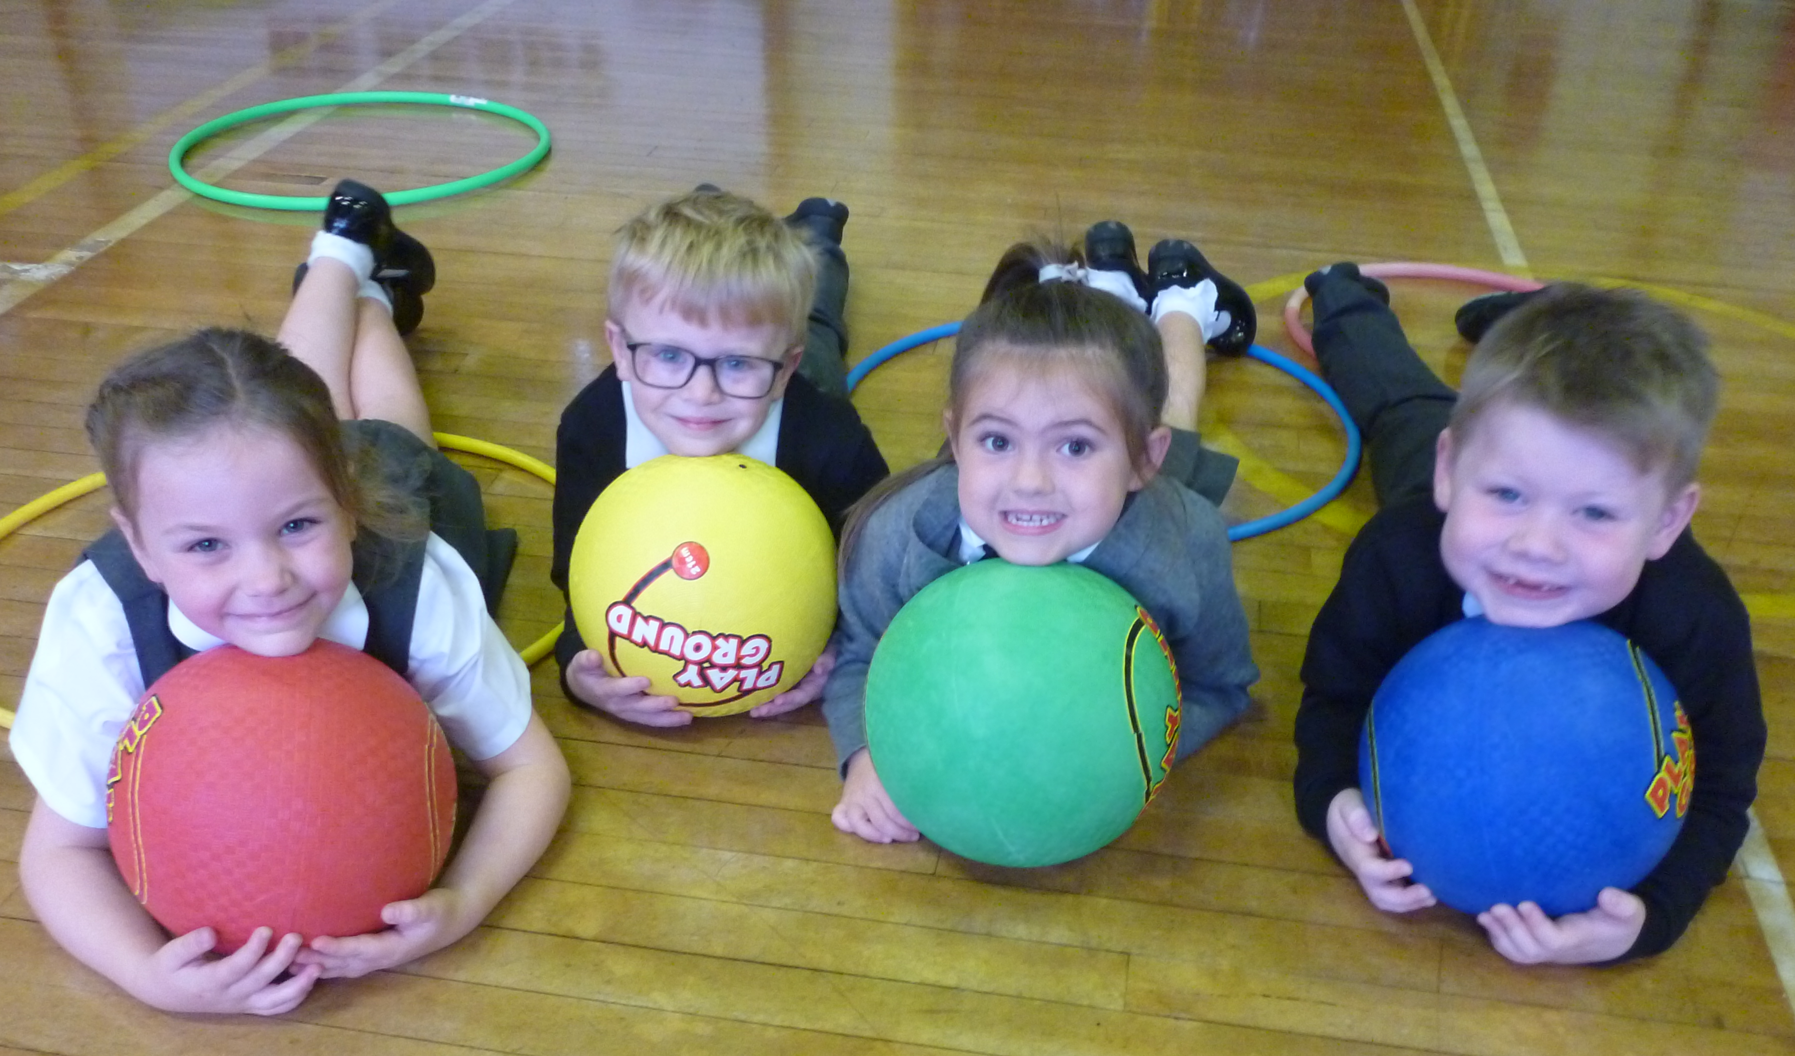
Parental
Information Pack
Primary 2

Working together for excellence

Welcome to Primary 2 Victoria Primary School

Hello Parents/Guardians,
We are very pleased that your child has now started Primary 2 in Victoria Primary School. This information pack is designed to support you and your child throughout this year. Please read the information included and if you have any further questions please contact school on 02893 351781. We look forward to meeting you at parental interviews and all other the various school community events that take place between September and June. Thank you for your support.

Contents

- Calendar information
- Information about Primary 2
- Maths topics
- Literacy topics
- World Around Us Topics

Calendar Information
2021/22

Please check the school website calendar for any additional dates.
Term Dates
August | Wed 25th – P2 – P7 return (half day and half classes – more info to follow)  Thurs 26th – P2 – P7 return (half day and half classes – more info to follow)  Fri 27th – P2 – P7 return (half day and full classes)  Mon 30th – School Closed (Public Holiday)
September | Wed 1st – P1 and Nursery children begin school. Specific dates and times will be communicated to individual parents.  Fri 24th – School Development Day (School Closed)
October | Mon 25th – School Development Day (School Closed)  Tues 26th – Fri 29th – Half Term (School Closed)
December | Tues 21st – School closes at 12pm for Christmas Holidays  Wed 22nd – School Development Day (School Closed)
January | Wed 5th – School reopens for all pupils in P2 – P7.  Nursery and P1 closed for Open Day.  Thurs 6th – School reopens for pupils in Nursery and P1.
February | Mon 14th & Tues 15th – School Development Day (School Closed)  Wed 16th – Fri 18th – Half Term (School Closed)
April | Fri 8th – School closes at 12pm for Easter Holidays  Mon 11th – School Development Day (School Closed)  Tues 12th – Fri 22nd – Easter Holidays (School Closed)
May | Mon 2nd – School Closed (Bank Holiday)  Mon 30th & Tues 31st – School Development Day (School Closed)
June | Wed 1st – Fri 3rd – (School Closed – mixture of holiday dates and bank holidays)  Thurs 30th – School closes at 12pm for Summer Holidays.
School Information

Principal Mr. Fulton
Vice-Principal Mrs. Kernaghan
Head of Foundation Mrs. Orr
and Key Stage 1
Head of Key Stage 2 Mrs Miskelly
Child Protection staff Mr Clarke/Mr Fulton /Mrs Addis/Mrs Kernaghan / Mrs Rodgers
Pastoral Care Mr Clarke
Special Education Needs Mrs Kernaghan
Chair of Governors Mrs Rodgers
Administrator Mrs Ritchie

School address Coronation Road
Carrickfergus
BT387EZ
02893351781
victoriaprimary@hotmail.co.uk

School Website www.victoriaprimary.org.uk

Parental information
Most parental information will be posted on the school website or sent out via our school app. (which is also accessible from SMART phones), including items such as canteen menu, holiday lists, monthly newsletters, policies and the welcome packs for each year group.

Queries
If you have a request or message Mrs Ritchie in the school office (02893 351781) will pass on information to your child’s class teacher or make an appointment to talk to the staff member you require. Information regarding how to discuss concerns or complaints will be detailed on the school website or this information can be obtained from the school office.

Who To Talk To?
As you will be aware we are a large school. Mr Fulton (Principal) and Mrs Kernaghan (Vice Principal) are always willing to try to talk to as many parents / carers should any issues arise, however, this may not always be the case. It is important, to ensure that any query or concerns is dealt with quickly, that you follow the flow chart below in terms of who to contact first. Please do not be offended if Mrs Ritchie directs you to an alternative person on the list to make contact with first.

Contact Flow Chart

Class Teacher

Head of Key Stage
Mrs Orr for P1 – P4 or Mrs Miskelly for P5 – P7

Vice Principal
Mrs Kernaghan

Principal
Mr Fulton

Pastoral Care and Special Educational Needs (SEN)
The aim of all staff is to meet the needs of your child. If you have a concern about pastoral care, please call school and ask to speak with the class teacher of Mr Clarke (Pastoral Care Lead). Or if you would like to speak with someone about additional educational needs for your child please speak to the class teacher or Mrs Kernaghan.

Child Protection
Parents are given Child protection leaflets, E:Safety Acceptable Use leaflets, Pastoral care leaflets, What to Expect in each year leaflets and notes about praise, punctuality, attendance, uniform and photographs. The Child Protection Policy can be obtained via the school website and or through the school office. See below for how a parent can raise a concern.

How a parent/guardian can raise a concern

I have a concern about my / a child’s safety

I can talk to the class teacher in the Nursery Unit
or Primary School

If I am still concerned, I can talk to the Designated Teachers for Child Protection/Safeguarding
Mr J. Clarke
Mr Fulton /Mrs Kernaghan/Mrs P Addis

If I am still concerned, I can talk to the Principal
Mr C Fulton (Principal)

If I am still concerned, I can talk/write to the
Chairperson of the Board of Governors -
Mrs J Rodgers c/o Victoria Primary School
& Nursery Unit

At anytime, I can talk to a social worker at the Gateway Services or the PSNI Public Protection Unit, Newtownabbey.

Primary 2 Information

General information

Room 7
Teacher: Miss Minnis
Classroom assistant: Mrs B Evans

Room 8
Teacher: Mrs Skillen
Classroom assistant: Mrs C Brown and Miss S May

The aim of the teachers in Primary 2 is to meet the needs of your child. It is a busy year for pupils, staff and parents as we together cover a very broad and exciting curriculum. Your support and interest is greatly appreciated.
We have an extremely high attendance rate in Victoria and believe it is important to your child’s learning that you support full attendance and punctuality. Please ensure that your child has uniform clearly marked with their name and that the uniform policy is adhered to (see website for details).
If you or your child has a question about school life or is unhappy about an issue please speak to your class teacher or other relevant staff members as outlined in school information above.

School times
School starts at 9.10am and P2 pupils can be in their classroom from 8:50am.
All P.2 classes enter through the side door in the mornings.
Room 7 and 8 exit through the side door at home time.

They are also welcome to attend our Breakfast Club in the school canteen from 8 – 8:50 am each morning at a small cost (contact school office).

Breaktime is from 10:30 – 10:45am and the pupils are encouraged to eat healthy break Monday – Thursday with a treat day on Fridays.

KS1 lunchtime arrangements:
12.00pm until 12.30pm packed lunch and dinners
12.30pm until 1.00pm outside play

The P2 week

Pupils will participate in Maths and Literacy lessons Monday – Friday. They will cover 5 topics over the year related to the ‘World Around Us’ (WAU). Please see below for details of these topic areas. They also participate in lessons in The Arts, PE, RE and PDMU (Personal Development and Mutual Understanding) much of which will directly relate to Maths, Literacy and WAU Learning Areas. Time will be spent using the Computer suite and school library. They will participate in a school assembly one morning each week.

P.E days - Mrs Skillen Tuesday and Wednesday

Miss Minnis Tuesday and Wednesday

All children must bring a t-shirt/school polo shirt, pair of black shorts and gym shoes to school in a suitable bag, clearly labelled with their name and class.

We also ask each child to bring in a painting apron and wellington boots clearly labelled with their name.

Any money given to the class teacher such as dinner money, snack money, milk money or trip money etc must be in an envelope clearly marked with what the money is for and how much money should be in the envelope. Please send correct money as no change can be given.
Please ensure all dinner money and snack money for the week comes in on a Monday morning.

Parent volunteers

For Victoria to provide as many opportunities and experiences during the school year we need your help!
The children go on various outings throughout the year and this requires the support of parents. If you are available to help please fill in and return the Parent Volunteer form available from the school office.

Homework

Reading: Monday – Thursday
Reading books will be sent home each night Monday – Thursday. Please ensure books are returned the next day in your child’s reading planner. Lost books will incur a replacement charge of £5. Talk with your child about the book – go on a picture walk. Listen to them read and ask their opinions about the book. Encourage them to use sound knowledge to help de-code unknown words. Play word games to reinforce new words. Please remember to sign the school planner each night.

Tricky Words: Please revise over the tricky words contained in your child’s planner throughout the year. It is important that your child is confident at recognising and saying these words to help with reading fluency and independent writing.

Written homework: Wednesday (please sign homework book and return to school by following Monday)
In a writing homework please encourage your child to attempt to spell words for him/herself, as we are trying to develop independent writing – ‘having a go’, rather than focusing on perfect spelling.

Mental Maths: Practise basic number and counting facts at home regularly. See school planner for ideas. Basic mental maths facts will also be tested in the Thursday test.

Spellings: These will begin in November. These are introduced in school on Monday and should be practised every night at home for the Thursday test. Your child will bring home their spelling practise book each night (Mon-Wed to copy out their spellings once each night). They will bring home their test book after the weekly test, for you to see, sign and return to school the next day.

Handwriting: We are following the Nelson handwriting programme where the letters incorporate a ‘flick’ style. Some children will need to practise weekly the formation of the letters c,a,d,g and o. ‘b’ and ‘d’ also prove problematic at this age so if your child is experiencing formation difficulties then use a variety of stimuli to encourage improvement e.g. use sand, lentils, paints, felt tip pens etc. Letter formation sheet included in school planner.
It is important for your child to form his/her letters correctly at this stage and it only improves with continued practice.

Jolly Phonics –We are following the Jolly Phonics programme.

P2 Curriculum topics

Below are the Maths, Literacy and World Around Us topics to be covered in each half term in school. All pupils will be provided with a wide range of appropriate, differentiated reading material throughout the year.
Half Term | Maths Topic
September - October | - Revise numbers 1-10 (formation, counting, ordering, what comes before, after and between etc)  - Number words to 10  - Quick recall of +1 +2  - Doubles to 12  - Numbers 11-15 (formation, counting, ordering, what comes before, after and between etc)  - Tree Diagram  - Carroll Diagram  - 2D shapes and their properties  - Patterns  - Capacity
October – December | - Counting to 40  - Quick recall of +3 +4  - Oral word problems  - Numbers to 20 (formation, counting, ordering, what comes before, after and between etc)  - Number words to 20  - Counting in 2s  - Money  - Partitioning numbers  - Length  - Estimating  - Simple Problem Solving
January – February | - Counting to 60  - Vertical addition  - Subtracting 1,2 and 3  - Partitioning numbers  - O’clock times  - Measuring  - Making amounts of money
February – April | - Subtracting 1,2,3 and 4  - Vertical subtraction  - Missing number sums  - Numbers to 30 (formation, counting, ordering, what comes before, after and between etc)  - Adding money  - 3D shapes  - Weight  - Half past times
April - June | - Ordinal numbers  - Counting in 2s, 5s and 10s  - Recognition of numbers to 100  - Written problem solving  - Money – change  - Bar charts  - Greater/ less than
English Writing Topics

A variety of writing genres will be covered throughout the year following the Treasure House Literacy Scheme.
Reading  The following skills will be covered throughout all areas of Literacy over the course of the year. | The skills are:  - clarifying,  - understanding words,  - sequencing and retelling,  - making connections,  - comparing and contrasting, predicting,  - summarising,  - visualising,  - questioning,  - speculating and justifying,  - identifying the main idea,  - concluding,  - inferring,  - fact and opinion,  - cause and effect  - finding information.

WAU Topics

September – October | - Clothes
November – December | - Light
January – February | - Our Senses
March – April | - Jack and the Beanstalk
May - June | - Wild Animals

*Please note that the above is set out for general information only and pace of learning and variations in school life may necessitate some change to the delivery and timing of these Learning Areas.

We hope you find this information useful. Please do not hesitate to contact us if you have any queries or concerns. Please also inform the school office of any changes to addresses or telephone numbers.
Many thanks for your support.

Mrs J. Skillen and Miss J. Minnis

